Casey Munsch
Flow Visualization
MCEN 4151-001
10/22/2018
Cloud Image
For this first assignment, I wanted to find a clear image of a cloud during sunset. I had taken multiple images throughout the weeks of the assignment, but most had turned out blurry or did not display the colors of the sunset. The final image I used was taken on October 3, 2108 at 5:00 PM in the Williams Village field.

The cloud that was captured is classified as Cumulus from it large fluffy shape and height in the atmosphere. Cumulus clouds are typically formed in unstable atmosphere with its base at an elevation of around 550 meters. In mountainous areas however, Cumulus Clouds can form at much higher elevations. Using the Skew T diagram shown in Figure 1, I found that that atmosphere was stable show by a CAPE value of zero [1]. Using the knowledge of the height and type of cloud, and the stability of the atmosphere, the Cumulus Cloud was most likely formed from the movement of air over the mountains causing updrafts that form these types of cumulus clouds.

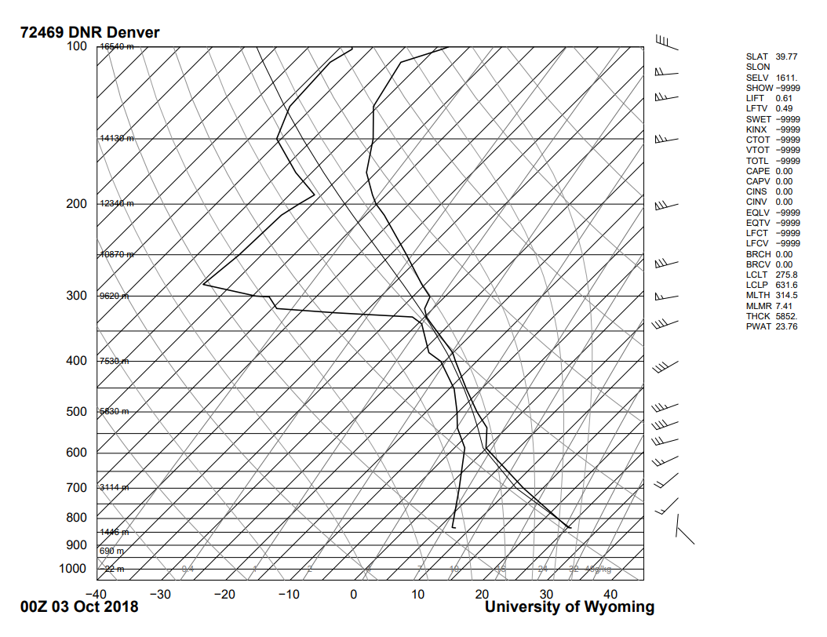
This image was taken at the start of a sunset and it was still relatively bright out. It was a clear day and the cloud in the image was one of the few in the sky at that time. The temperature was around 65 degrees Fahrenheit and the previous and following days were clear, warm days.
Figure 1: Skew T on October 3, 2018 provided by the University of Wyoming
College of Engineering
Using an iPhone camera, the image was taken with a built in function called High Dynamic Range with its fixed f2.2 lens. This setting is used to clear up the darker sections of the image. The shutter speed was set to 1/60 seconds with an IOS of 400. In post processing, the image was brightened and the contrast was increased slightly. The image was also rotated so the rooftop on the bottom left of the image was flat.

Overall I think the image does a good job portraying the cumulus cloud and captures the lights of sunset. If I were to retake this picture I would try to capture the cloud without getting any buildings in the image. I would also try to play around with the exposure settings a little more now that I know how to use these settings a little better.

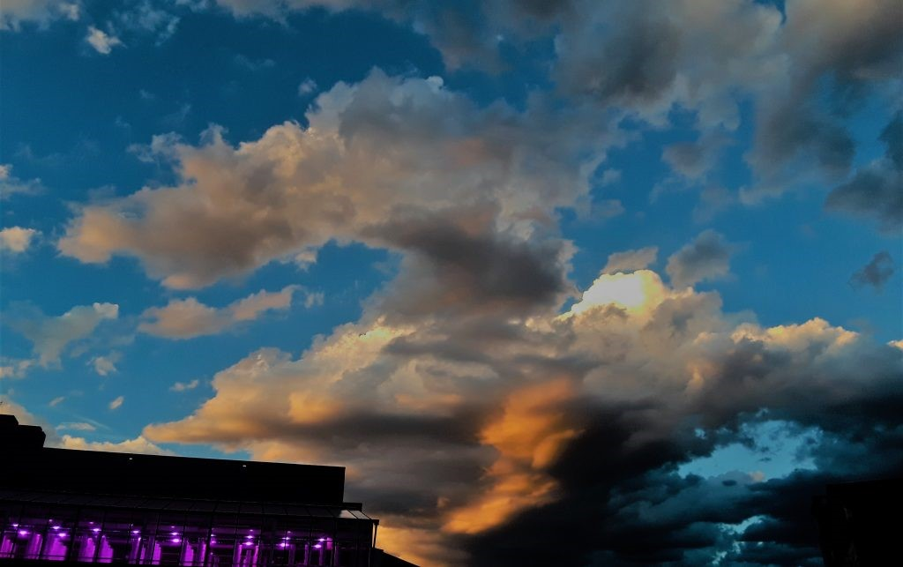

Works Cited
[1] “Atmospheric Surroundings .” Atmospheric Soundings, University of Wyoming College of Engineering, 3 Oct. 2018, weather.uwyo.edu/upperair/sounding.html.

