Second Team Image Report

Brent Eckles

MCEN 4151-001

7-Nov-18

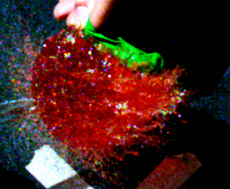

Introduction:
This image was produced in response to the second team project assignment for Flow Visualization as the second opportunity to work as a group and presented the opportunity to further improve image capturing techniques. The idea for this image came form the excitement over the High Speed Slow Motion camera which was presented in class. The team wanted the opportunity to work with the camera to be able to capture the physics in flow at an extremely slowed down rate. After brainstorming several ideas in which to utilize this camera, the team decided to pierce water balloons filled with a mixture of water and coloring dye for the project. The team felt this project would provide substantial experience with working with the camera and further its abilities with staging practices.

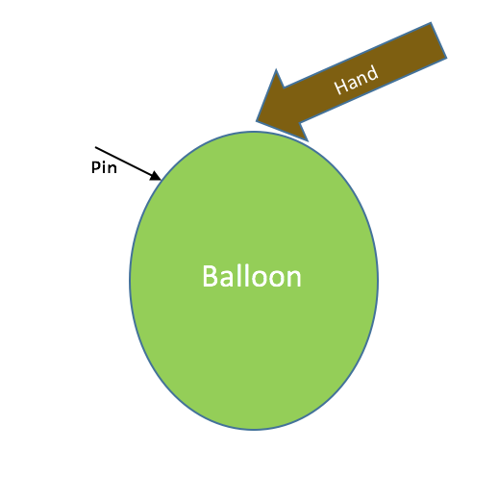
Experimental Setup:
The materials used in this project were water, food dye, balloons, and a sharp object. First several balloons were filled up using the ITLL sinks, next an assortment of food coloring dyes were dropped into the balloons. The food dye was used in order to increase the visibility of the flow involved. The balloons were then tied off and brought to the staging area. The High Speed Camera was set up so that it was directly facing an opposite wall, with the sun shining overhead and illuminating the contents of the wall. The camera had to be directed in on a very narrow X marked on the wall where the balloons were to be popped. The camera had to be started by first pressing the trigger button and then capture. This is due to the large quantity of photos the camera takes so this process limits the data used. The balloons were then held up within the cameras shot and pierced with a sharp object. This process was repeated several times capturing bursts of images for each attempt.

Flow Analysis
The events that lead up to the balloon being popped and its eventual release of the water are characterized by both pressure and gravity. Due to the elastic characteristics of the balloon its volume is not constant and can be increased or decreased due to the amount of fluid captured in the balloon. As more water is added to the balloon it stretches the rubber material and expands the volume of the balloon. As this volume increases the elastic material begins to push more and more inward toward the contents of the balloon. However, due to the elastic material pushing on the water, it responds by pushing outward with the same amount of force, this force is called pressure. This pressure remains constant once the balloon has stopped being filled up and is contained within both the balloon and water. The experiment is done by pressing a pin into the side of the balloon. This piercing of the balloon immediately releases the pressure from within the balloon, however the force still instantaneously acts on the water within. This pressure force acts perpendicular to the wall on the balloon on the water particles. This is what causes the exploding affect which can be seen, pressure instantaneously acting on the water within without the balloon material pushing back. This phenomenon happens extremely quickly which is why a camera taking continuous photo’s must be used. The other force which acts on the balloon is gravity. This force is always acting on both the water and the balloon. However, upon the popping of the balloon there is no force from the balloon to hold the water up. Due to this force imbalance the force of gravity takes over and pulls the water down to the ground splattering the water. The forces acting on the balloon can be seen in Figure 2.

Figure 2 shows the force the water is applying to the surface of the balloon as well as the force of gravity acting on the water and balloon.

Camera Specs & Photo Editing
The Camera used for the capturing of this image was the High Speed Camera rented out from the ITLL at the University of Colorado. The camera was set to capture 2500 pictures per second. After capturing the large quantities of photos they had to be sorted through in order to select the perfect image. This image displayed two main characteristics, a detailed image in focus as well as one that captured the initial event of the balloon popping as best as possible. Once this photo was selected it then had to be edited allowing for the optimization of the photo. The image was uploaded into gimp, an editing software with several image editing options. Two main things happened to the photo, one it was cropped and two the color curve was adjusted. As can be seen from Figure 3 the original photo captured a much larger area, with the main events of the picture not in the center of the photo. The picture was cropped to place the balloon in the middle of the photo but also allowed for both the hand and the balloon residual to be captured in nice corners of the photo.
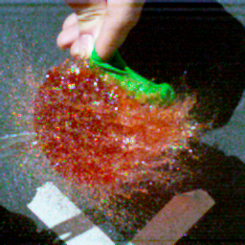

Figure 3
Figure 3 also shows the changes made to the coloring of the photo. The goal of the editing was to make the water captured the main focus of the photograph. To do this the darker colors in the image were made much darker without effecting the lighter colors. This created a larger contrast between the wall and the water. Additionally, this took the brightness out of the hand giving the hand warm characteristics. The adjustment of the color curve is contained in figure 4 below.
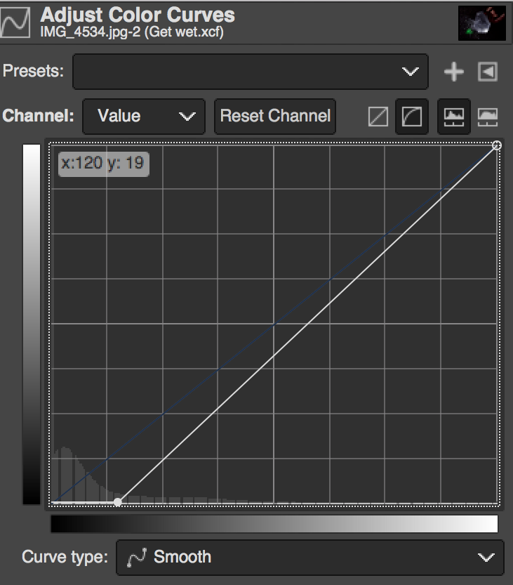

Figure 4
Conclusion:
The second team project gave the opportunity to revisit the experiment done for the get wet assignment. Overall the second experience produced a image with far less picture quality than the original experiment. This was do to the camera used. The high speed camera while offering the ability to capture a large amount of pictures per second the quality of the image is effective. This camera should be used to better understand the events of an experiment but not necessarily to produce works of art. The photo is cool in the way that it shows what is going on in the photo in a very frozen way. The image would be spectacular if the resolution and the quality were much better.

