Fig 1: Mixing of a Coffee and Creamer

Get Wet- Fall 2023

Venkata Durvasula

MCEN 5151

**Purpose**: As someone who drinks coffee every day, I was always fascinated by the pattern generated when the creamer settles into coffee. I tried to capture the pattern by mixing cold black coffee with half and half creamer with the help of my friend Prashamsa Natti, who poured the creamer into the coffee while I was capturing the image.

Fig 2: Setup

**Setup and Discussion:**

For the setup, I took coffee in a glass and creamer in another glass. The glass was about 4” tall and 2” in diameter. I set both the glass and the camera on the floor at 10” apart. As the creamer was poured into the coffee a swirling motion was observed which is caused due to gravity and the differences in the densities of the fluids. There are two fluid phenomena that are in play. Rayleigh- Taylor instability causes the fluids to mix to form a more stable mixture and Kelvin-Helmholtz instability causes the swirling motion in the liquids. The Reynold’s number can be approximated to,

R= $\frac{UD}{ϑ}$ = $\frac{0.05×0.0508}{0.0000011385}=2231$

A Reynold’s number of 2231 indicates that the flow is transitional, as the creamer was poured into the glass, the initial gush of creamer into the coffee was turbulent and it began to settle down and mix with coffee. As the coffee and creamer mixed perfectly without the help of a stirrer and as the creamer was poured from a height of 4 feet (my friend was standing while pouring the creamer), due to the effect of gravity, which resulted in a higher jet (creamer) speed, that caused the flow to be turbulent.

The velocity was calculated by ho much the fluid has moved in between each shot, which was captured every 0.5 seconds. A Reynold’s number of 2231 indicates that the flow is turbulent. This means that when the creamer.

**Photography and Specifications:**

To capture this image, I took a coffee in a glass and had my friend pour the creamer. I set this up in a room, closed the curtains to block sunlight from entering the room. I then turned the lights on and adjusted the brightness so that it is not dark and had just enough lighting to capture the image. I used Starbucks Pike place roast coffee and a half and half creamer. I set the camera on the floor 10 inches apart. I then set the camera on auto mode and used the 10 continuous shot setting on the camera. I then had my friend pour the creamer and captured 10 shots all the way from the initial gush to the complete dissolving of the creamer in the coffee. The raw image is shown below.

Specs:

* Camera- Canon rebel T3i DSLR
* Lens- 18-55 mm
* ISO-800
* Focus- 6.3mm

Post processing was done using Darktable, where the original image[3]was cropped and edited to the one seen above[1]

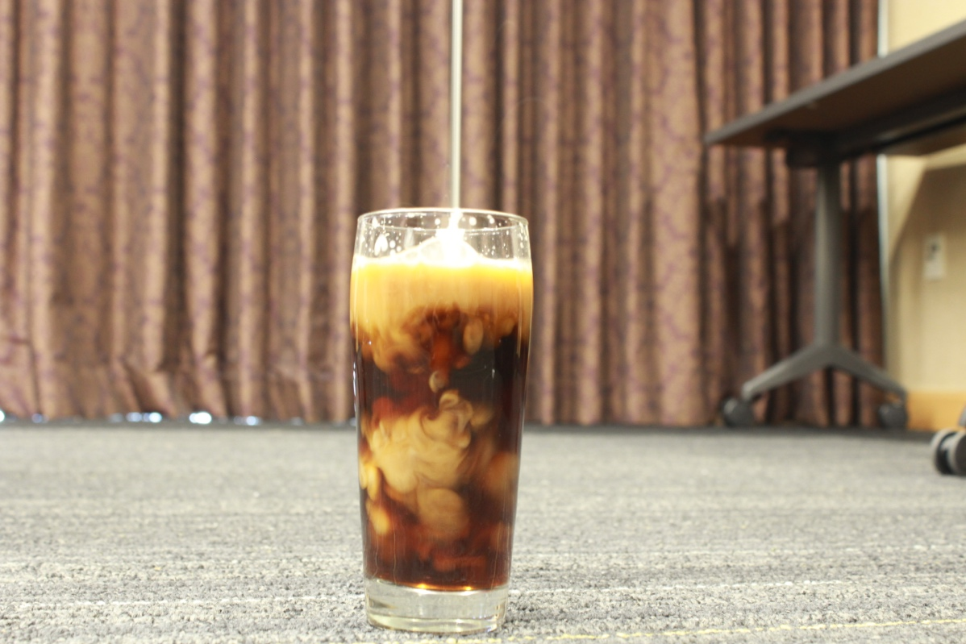

Fig 3: Raw image

**Conclusion**:

The image illustrates some interesting fluid phenomena occurring when you mix coffee and creamer. I like the contrast between the two fluids. The image was captured in Jpeg format, and if I wanted to improve the image, capturing the image in raw format of the camera, increases the pixel resolution which leads to better clarity. I used auto setting to try and optimize the camera and if tried manual settings and increase the ISO and shutter speed manually to get more pixel resolution, resulting in a better image.

**References**:

1. A. R. Piriz, O. D. Cortázar, J. J. López Cela and N. A. Tahir, “The Rayleigh-Taylor Instability”, American Journal of Physics 74, 1095-1098(2006).

# Hyun Geun Lee, Junseok Kim, “Two-dimensional Kelvin–Helmholtz instabilities of multi-component fluids”, European Journal of Mechanics B/ Fluids 49(2015) 77-78.