Team First Report
Alexandr Vassilyev
Team Snap Peas: Abhishek Raut, Alexandr Vassilyev, Haotian Chen
MCEN 5151: Flow Visualization
University of Colorado Boulder
10/6/2023
Context and Purpose
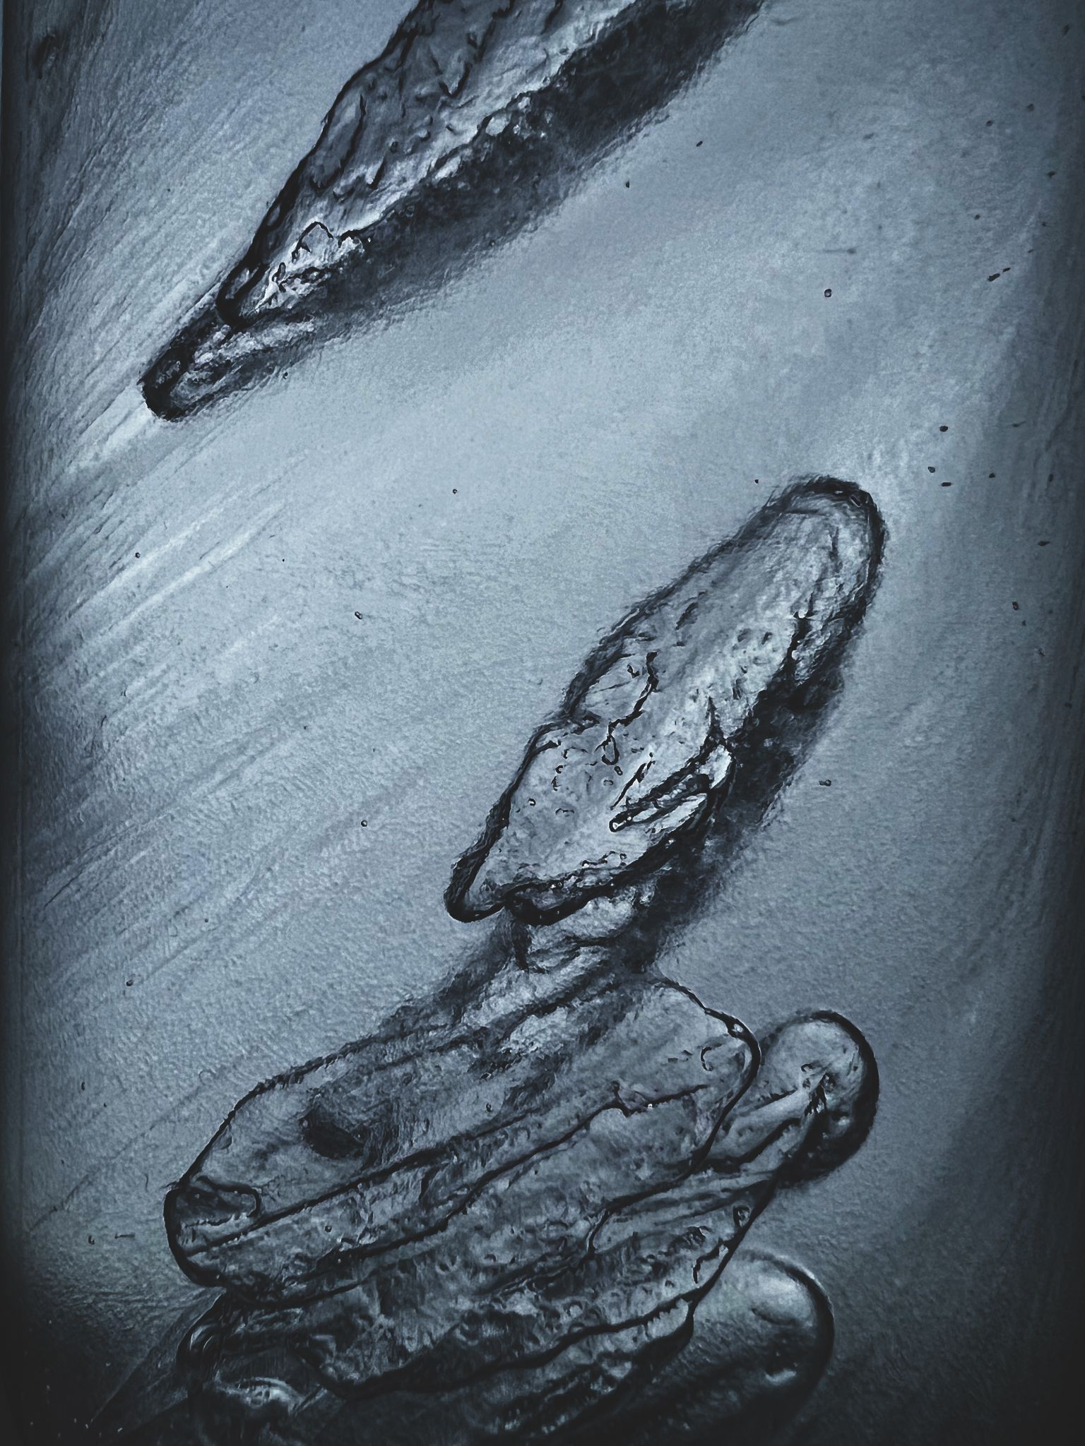
Figure 1: Processed image of supercooled water

Supercooling and snap-freezing are two processes that work in conjunction to form interesting crystal structures. Team Snap Peas (Abhishek Raut, Haotian Chen, and Alexandr Vassilyev) chose to study this phenomenon for the Team First assignment of MCEN 5151: Flow Visualization. The intention was to create an experimental design of how to achieve supercooling and snap freezing, and then to document its occurrence through photos and videos. The team worked together, having Haotian Chen provide materials to create the mixtures used for snap-freezing and supercooling, and Alexandr Vassilyev and Abhishek Raut designing the experimental setup.

Flow Apparatus
The experimental setup used to capture snap-freezing via supercooling was quite simple. The materials needed to recreate the experiment were as follows: distilled water, salt, transparent container (water bottle, Tupperware, etc.) and an infrared thermometer. The team chose to use a 20oz plastic water bottle which was filled nearly to the rim with distilled water, and then added 0.75ml of table salt. Once the bottle is sealed it must be placed in a freezer and monitored via the infrared thermometer until it reaches a temperature between -1 to -3°C (supercooled). Once this temperature range is reached, the bottle must carefully be removed from the freezer. After removing the bottle, our team placed it near a strong light source for photographing. The bottle is then shaken or knocked forcefully in order to induce snap-freezing, as shown in this video taken by the team during the initial attempt: youtube.com.
Snap-freezing occurs after a force is imparted on the mixture, causing crystals to form around the salt (which are nucleation sites). Depending on the orientation and stability of the water bottle, these crystals can either form in planes or as separate entities. For this specific report, the water bottle was held diagonally, causing crystal planes to form along that direction. The spatial resolution can also vary greatly, however in this instant snap-freezing occurred instantly, meaning at the time the photo was taken the mixture was static.
The Reynolds number is estimated below:
$Re = \frac{ρuL}{μ}= \frac{(Estimated speed of snap freezing from top to bottom of water bottle)(D water bottle)}{water @ 0C}=\frac{10m/s*0.09m}{1.791*{10}^{-6}m2/s}$Re = 502512

This high of a Reynolds number indicates turbulent flow, which is certainly what happens during snap-freezing. Once the mixture is fully solid, this flow is still able to be seen via the crystals formed during flow.

Visualization Techniques
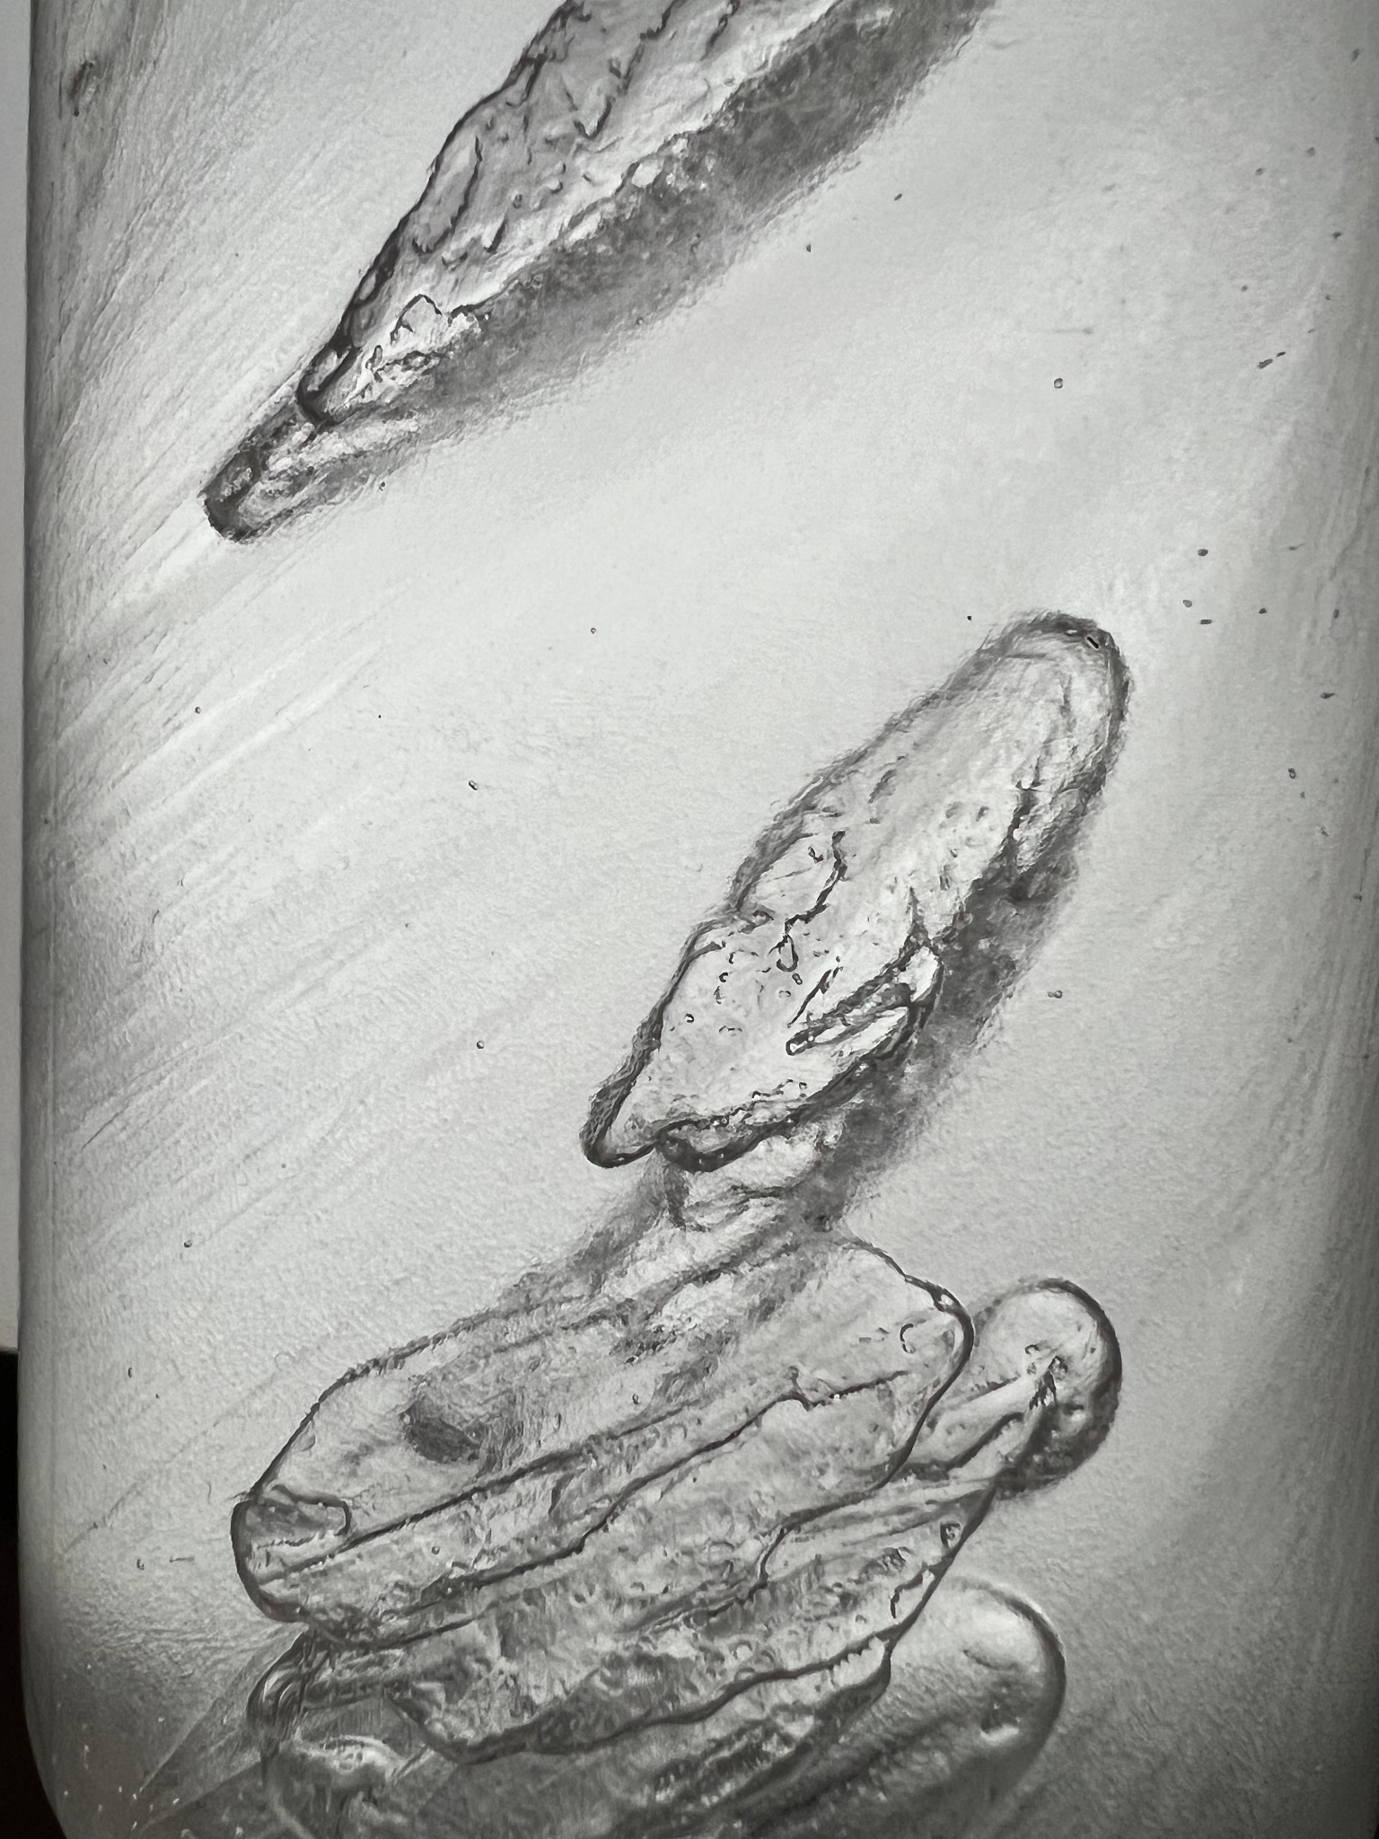
Figure 2: Original unprocessed image

To photograph snap-freezing via supercooling, several additional supplies were needed. To stop condensation and capture a clearer image, detergent was applied to the surface of the water bottle. The light source was an iPad Pro placed behind the water bottle, emitting roughly 1600 nits. More information regarding the camera's settings are listed below.

Photographic Techniques
Mild edits were made to create the final image. The color grading was adjusted to highlight more blacks and blues as this emphasizes the edges of the crystal planes. The white balance was adjusted to compensate for the overly bright lighting conditions from indoor lighting. Finally, the image was cropped to cut out the distortion on the edges caused by the water bottle’s cylindrical shape.

Camera information is listed below:
- Camera: iPhone 13 Pro (Editing via Lightroom)
- ISO: 125
- Focal Length: 28mm
- Exposure: f1.8
- Object-to-Lens Distance: 5.5cm
- Image Dimensions: 2966 x 3954px (3:4)

Comments on Image
Overall, I thought the image was interesting in that it was able to capture what is normally turbulent flow in a static state. The dynamic range is excellent in that it reveals the individual crystal planes. Most of all, I enjoyed the experimental setup needed to capture this image, as being able to observe snap-freezing and supercooling is quite impressive in person. Some factors I dislike about this image is the quality, as there was still contestation on the water bottle that distorted the clarity of the crystal structures inside. I would improve this through using a glass container and taking the images in a much colder room. To develop this idea further, I would use different materials instead of salt for nucleation sites, and experiment with more container shapes.

References

Acknowledgements: Team Snap Peas - Abhishek Raut & Haotian Chen

Science Buddies Staff. "Supercooling Water and Snap Freezing." Science Buddies, 20 Nov. 2020,
https://www.sciencebuddies.org/science-fair-projects/project-ideas/Phys_p033/physics/su
percooling-water-and-snap-freezing. Accessed 6 Oct. 2023.

“Instant Freeze Super-Cooled Water.” Cool Science,
www.coolscience.org/cool-chemistry/instant-freeze-super-cooled-water. Accessed 6 Oct.
2023.

