Team First Report 2023 – MCEN 5151 Flow Visualization Jessica Holmes
Shishito: Cameron Sprenger, Maddie O’Brien, Nicole Nageli Oct. 6th, 2023

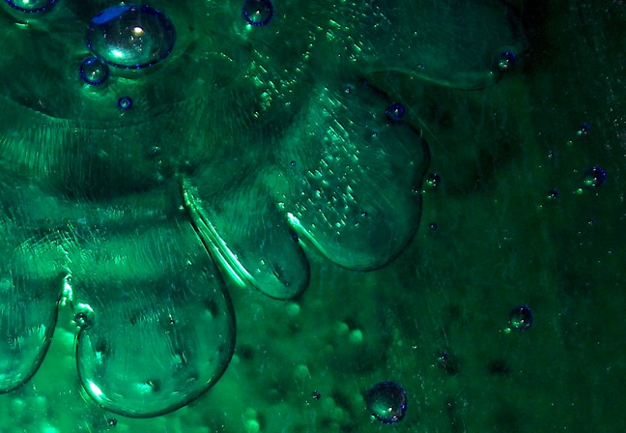
As an applied mathematician interested in fluid dynamics, I have studied a handful of well-known fluid instabilities but had not had the chance to recreate them physically until now. This image was an experiment with a flow instability, namely the Saffman-Taylor instability, that I was previously familiar with but had only studied on paper. I took this project as an opportunity to explore the design and fabrication process of building an apparatus of my own and applying it to produce an exciting image for those unfamiliar with this instability. Thanks to my teammates, Cameron, Maddie, and Nicole, for their moral and physical support. They did not aid in making this photo per se, but each was present at some point in the experimental process that led to this result.

The Saffman-Taylor instability arises when you displace a more vicious fluid with a less viscous fluid, causing a finger-like morphology at the interface between the two. In the inverse situation, with the more viscous fluid displacing the other, the interface is instead stable. In this case, water was injected into green dye-colored corn syrup.

This instability resembles the more well-known Rayleigh Taylor instability at low Reynolds numbers. The same effect occurs in both systems, except one is driven by pressure and viscous variability between fluids, and the other is driven by gravity and density variability between fluids, respectively. In either case, the initialization of the instability depends on the spatial position of the fluids relative to one another. Most experimental research on this phenomenon is performed within a Hele-Shaw cell, consisting of two parallel sheets of glass separated by a small distance and then filled with a viscous fluid. We used a radial configuration, where the fluid is injected into the cell's middle, resulting in a circular flower-like pattern.
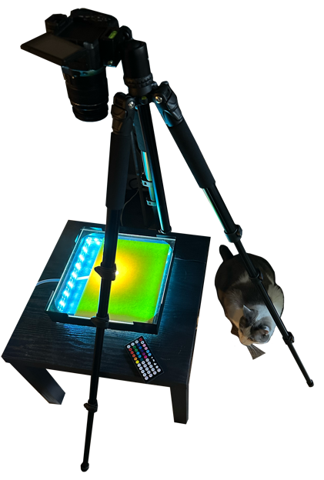
Mr. Man
Credit to my cat, Mr. Man, for inspecting the safety of my procedure.
To capture this phenomenon, I built my apparatus. The apparatus comprises a 2.5-inch-thick shadow box lined with RGB LED lights on the inner walls. The corners of the shadow box are lined with inverted corner protectors to corral three plexiglass pieces in line with the box. One 5/8'' diameter hole was drilled in the center of two plexiglass pieces to hold the tube into which a syringe injects the less viscous fluid. Two pieces of plexiglass were drilled to allow for colored construction paper to sit in between the two sheets to act as a background/diffusion of light. However, the background is not present in my final image as I only used two pieces of plexiglass, 1 with a hole for injection and one fully intact. For each run, I first filled the syringe and tube with water to prevent the presence of air bubbles within the cell. Then, I layered the bottom plexiglass with a thick glob (technical unit) of corn syrup before covering it with the top plexiglass piece. I used a mixture of green and blue Signature Select Food Coloring from the brand in Market Pantry Corn Syrup (light with real vanilla) between the plates. Then, you slowly inject, resulting in the familiar finger-like protrusions this instability is known for.

A Hele-Shaw cell thus can be seen as a model system for a porous medium with permeability inversely proportional to the fluid's viscosity. In other words, the thinner the cell and the more viscous the fluid, the harder it is to permeate through the cell.
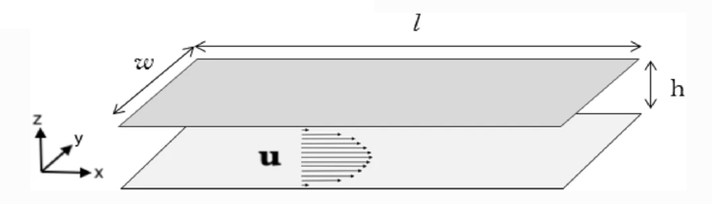
At leading order, the pressure-driven flow in the cell has a Poiseuille profile, and the situation can be described by a depth-averaged two-dimensional potential flow model, where the mean velocity of each fluid is defined by the Hele-Shaw approximation.
(Fast and Shelley, 2005)

The Hele-Shaw approximation is an adaptation of Darcy's law, which illustrates that fluids with large permeability move faster under the action of a given pressure gradient compared to fluids with smaller permeability (Gallaire, 2017). The Hele-Shaw approximation for the mean velocity within the plane is,

$u_{i}=-\frac{b^{2}}{12μ_{i}}∇p_{i }$,

where $i = 1, 2$ are the two different fluids, $b$ is the cell gap, $μ_{i}$ is the dynamic viscosity of the
with fluid, $K_{i}=\frac{b^{2}}{12μ_{i}}$ is the absolute permeability, and $∇p_{i}$ is the pressure gradient in all directions. Because of the incompressibility of the depth-averaged flow, we see no change in the pressure from the bottom to the top of the cell. Therefore, the pressure gradient is comprised of a horizontal component. The pressure was not measured in this case, but we can calculate the permeability of both fluids. Since water has a dynamic viscosity of 1 centipoise or 10⁻³ $Pa∙s$, corn syrup has a dynamic viscosity of 3 $Pa∙s$, and b = 3mm=.3cm, then,

$$K_{water}=\frac{0.9 cm}{12∙0.3 Pa∙s}=.25 s/g, K_{corn syrup}=\frac{.9cm}{12∙3Pa∙s}=.025 s/g.$$

Therefore, water is ten times more permeable than corn syrup. This flow also exhibits a very small Reynold's number, considering the slow velocity and the dominating length scale, i.e., the cell's width is small. Therefore, viscous forces dominate, resulting in an organized laminar flow.

As seen in Figure (a) to the right, by the contours of the pressure field, any emerging finger enhances the pressure gradients acting at the tip of the finger. We create a feedback loop because the "interface moves with a velocity proportional to the pressure gradient"( Gallaire, 2013) Therefore, initial displacement will quickly turn unstable as it increases the "pressure gradient and further accelerates a protruding finger" (Gallaire, 2013).
In this case, a small coffee table elevated the Hele-Shaw cell while the camera towered directly above. This gave an undistorted view of the instability. The field of view is approximately 3x4 inches, digitally cropped from the original photo. The camera, a Canon Rebel 3Ti, was placed 1.5 ft away from the apparatus. The flash was used for this photo unintentionally, but it yielded a beautiful result. Pictured below is a comparison between the original photo and the final edited version, along with the metadata of the final image.
(Gallaire and Brun, 2017)
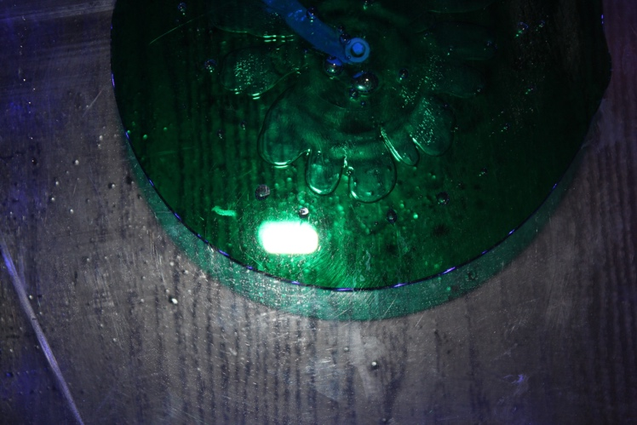

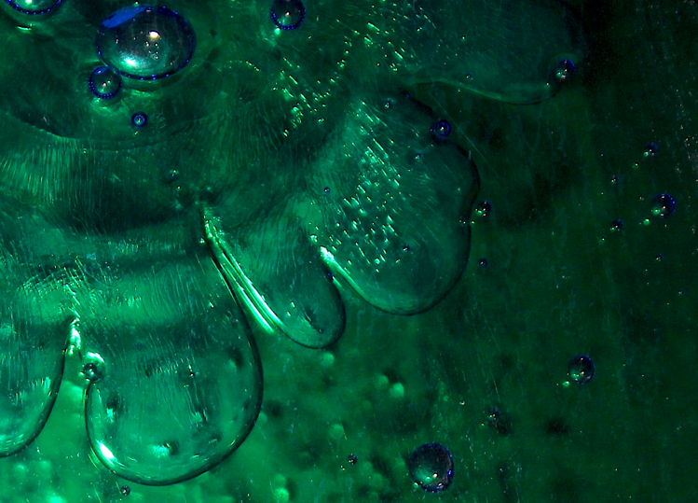
5184 x 3456

1555 × 1120

Minimal post-processing manipulations were used. To adjust for the loss of clarity in the dark regions, I slightly increased the image's exposure. I then increased the saturation by about 3% and the sharpness by about 20%.

The result shows the classic finger-like protrusions but coupled with other fluid artifacts. Notice how the air bubbles originating in the corn syrup interact with the fingers of the water. The bubbles are passed/engulfed by the interface, indicating they are not moving with the water but are being surpassed by it. The air bubbles in the flow also reflect the LED lights on the interior of the apparatus beneath the flow. In contrast, the interface of the water and syrup primarily reflects the camera's flash. The shadows of the flow are reflected on the table on which the apparatus sits. The small aperture of f/5.6 gives a small depth of field, which worked to our advantage, making the lower reflection less distracting. Details are lost in the shadows of the top right corner, which a higher ISO could improve. There are also streaks from the corn syrup residue from past runs, most visible on the right-hand side of the photo. I needed to pay more attention to detail when cleaning the plates after multiple runs, which I can improve next time by being more diligent about details within the setup. Another improvement for next time would be to use glass plates, as opposed to plexiglass, which has a smaller injection hole. The plexiglass plates were too flexible, creating uneven spacing between the pieces. The injection hole was too big in this case, which resulted in stubby, short fingers, whereas a smaller injection hole would have resulted in smaller, interesting fingers. These are my most significant concerns for the apparatus and procedure.

References
Brun P.-T., Gallaire F. Fluid dynamic instabilities: theory and application
to pattern forming in complex media. The Royal Society Publishing, A.
375:32–34, 2017.

Gallaire, Nagel, Mathias, and François. "A New Prediction of Wavelength Selection in Radial Viscous Fingering Involving Normal and Tangential Stresses." Physics of Fluids, 2013, https://doi.org/10.1063/1.4849495.
Shelley M, Fast P. Moore’s law and the saffman–taylor instability. Elsevier:
Journal of Computational Physics, page 2, 2005.

