Clouds Second Report

Riley Menke
MCEN4151: Flow Visualization
12/16/23

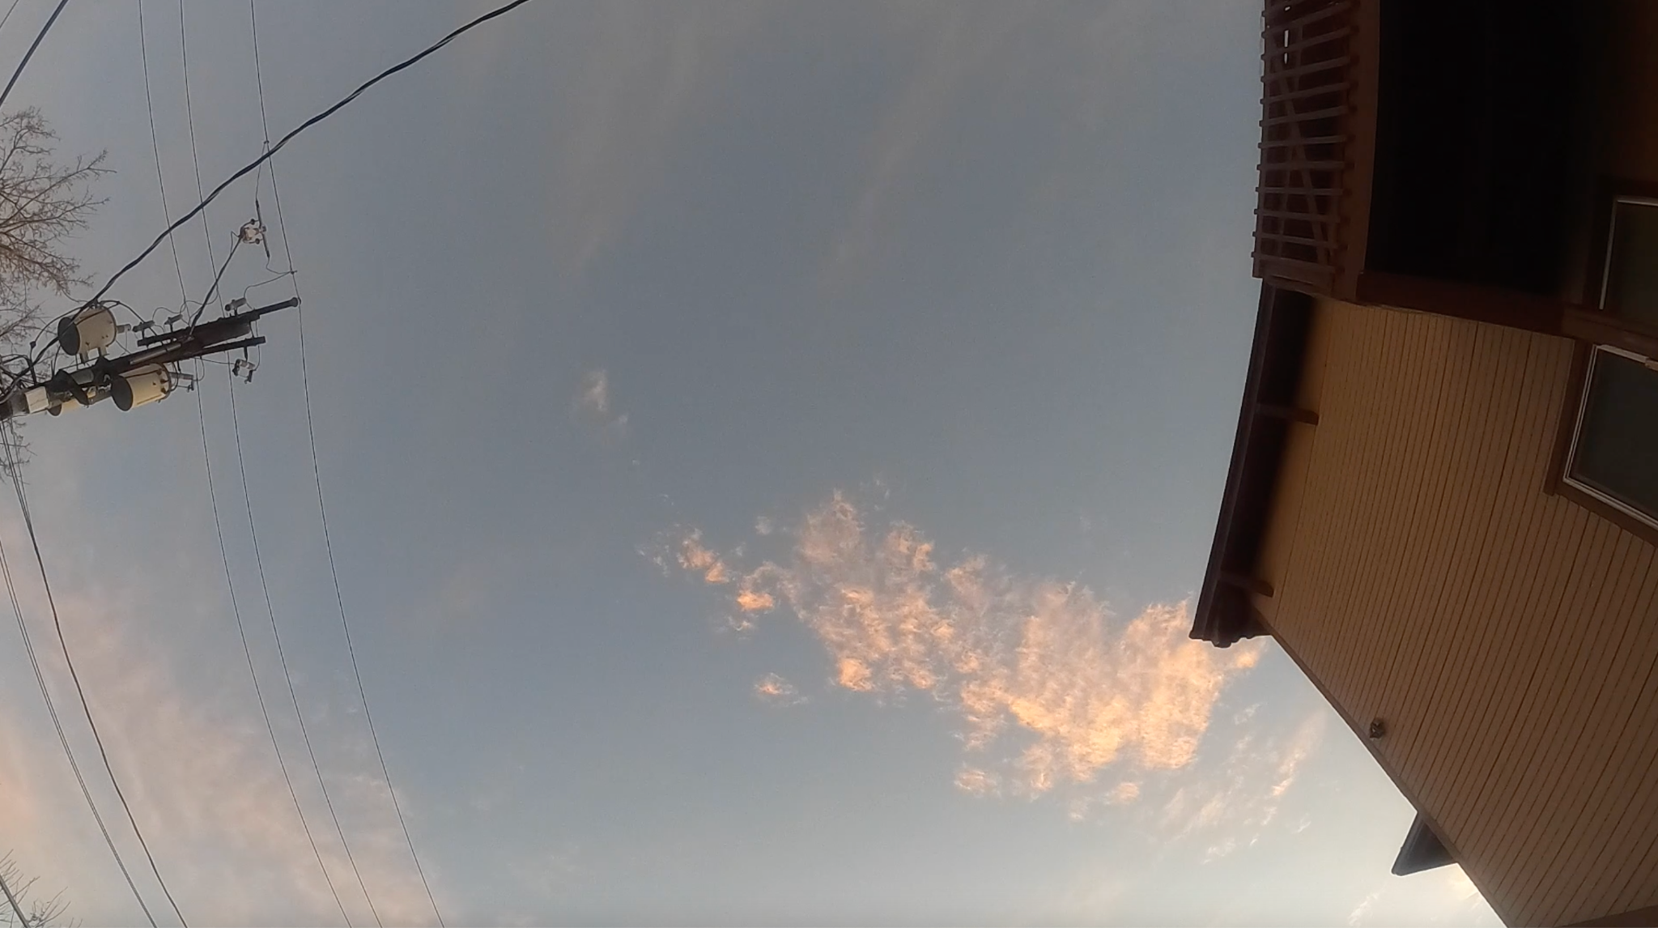
Figure 1: Photo taken as a frame from the video posted to Youtube¹. The camera points East at the footing of the Sanitas Mountain range on the morning of December 3rd, 2023 taken by Riley Menke using a GoPro HERO9 Black.

Background
For this cloud assignment, I chose to capture atmospheric flow by recording a video rather than taking a still image. By doing so, I was able to deduce multiple factors that contribute to the formations seen in the featured image in Figure 1. The condensation of air serves as a great means of seeding the fluids in our atmosphere. This recording in particular shows the altitude of condensation and direction of the air masses very well.
This video was taken the morning of December 3rd, 2023, at 7:30am, just after sunrise. Although the camera is mainly pointing up, it is still facing east, placed in north Boulder, just below the footing of the Sanitas mountains. The video shows multiple cumulus clouds forming, just luckily above the camera. It is for this reason, and the location of the camera that give me reason to believe that they are Cumulus Lenticularis clouds.
I chose this picture as my submission for ‘Clouds Second’ because I liked how speeding up time changes the flow perspective of clouds. I also appreciate the convenient condensation of the atmosphere, and the timing of the jet that flies across the screen. The combination of these attributes makes for a pleasing short video.

Cloud Classification
As briefly discussed, this footage gives reason to argue that these are a type of lenticular clouds. Particularly Cumulus Lenticularis clouds, characterized by their fluffy nature. Compared to most formation of clouds, these are not caused by temperature instability throughout the atmosphere. There is a hint to this in the relative formation location of the clouds; As the video progresses, the viewer may notice that the moment of formation does not move at all while the recording takes place. On the other hand, if air rising due to temperature caused these clouds, they would be moving with their air masses, not remain stationary.
So what causes these clouds and why are they stationary? The air that flows over Sanitas peak just behind this frame is the answer. Similar to that of waves crashing and cresting in a body of water, the air in the atmosphere can crest at the peaks of waves. The Cumulus Lenticularis clouds seen in Figure 1, are visualizing this phenomenon of waves of air flowing over the mountains and crashing down into the valley on the other side.

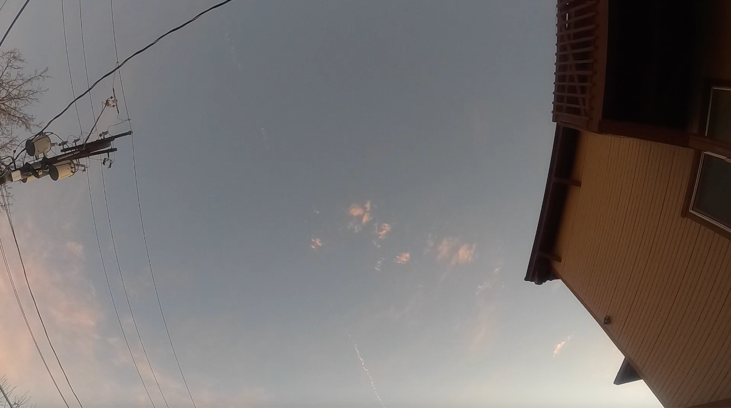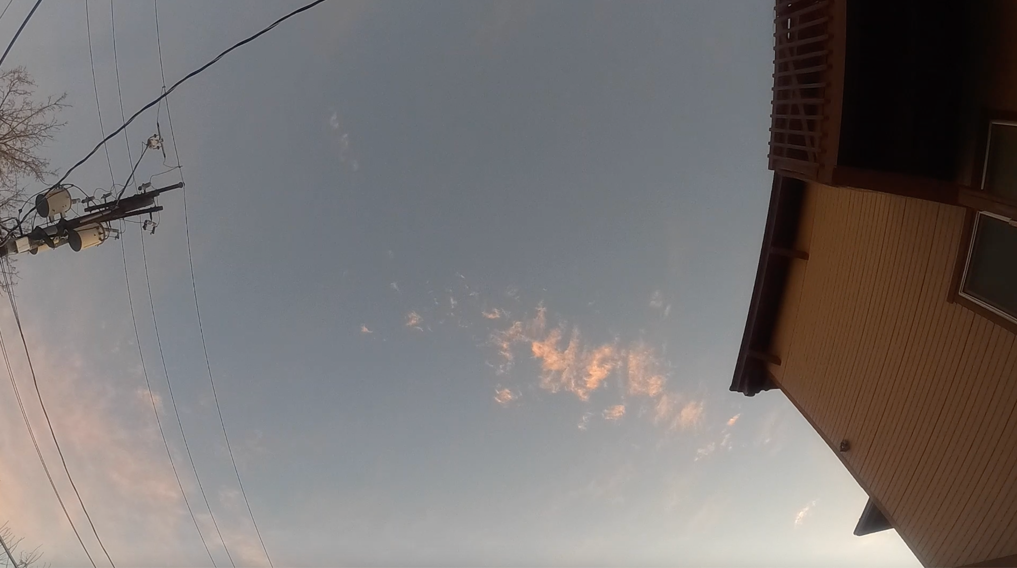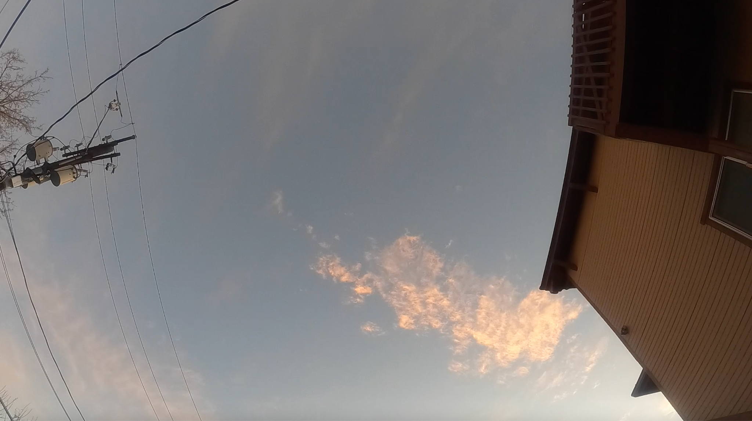
Figure 2:Frames from the video at 0.3 seconds, 0.5 seconds and 0.7 seconds to outline that the formation of clouds is happening in the same location inside the frame.

Figure 2 above helps to index where the formation of clouds is occurring. In these thre frames, spaced 2 hyper seconds apart, you can see that the leftmost part of the cloud formation is always in the same position in the frame. This is where the crest of that wave would be. As it comes clowning up and breaking, it is condemning in the same spot, like waves flowing over rocks, and so we get the Cumulus Lenticularis cloud formations seen in Figure 1 and in the video posted¹.

Skew-T
To further analyze these formations in the Boulder sky, I used the Skew-T graph seen in Figure 3. These were taken from the Salt Lake city weather station on the morning of the 3rd.

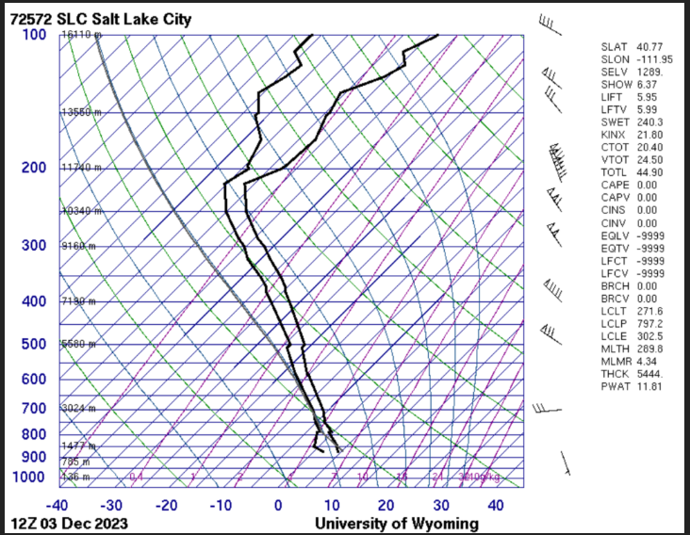
Figure 3: Skew-T graph taken from the SLC station at 7am on December 3rd, 2023.

From the Skew-T data, it can be further deciphered how these clouds are condensing. From the graph, it is clear how close the temperature and dewpoint lines are across a wide range of pressures. This explains why the breaking atmospheric waves are condensing into clouds. The lines being this close to one another means that it only takes a small change in temperature for a parcel of air to become saturated, and thus seed the atmospheric flow as a cloud.

Historical Weather
Because this type of cloud is less dependent on temperature difference induced instability, reading the historical weather data surrounding this cloud formation is less significant. What can be gathered from this graph in Figure 5, is the reason parcels of fluid may have decreased temperature and thus condensed, as is shown on the Skew-T graph. Seen below, the morning of the 3rd was actually warmer the night before than it was when the picture was taken.

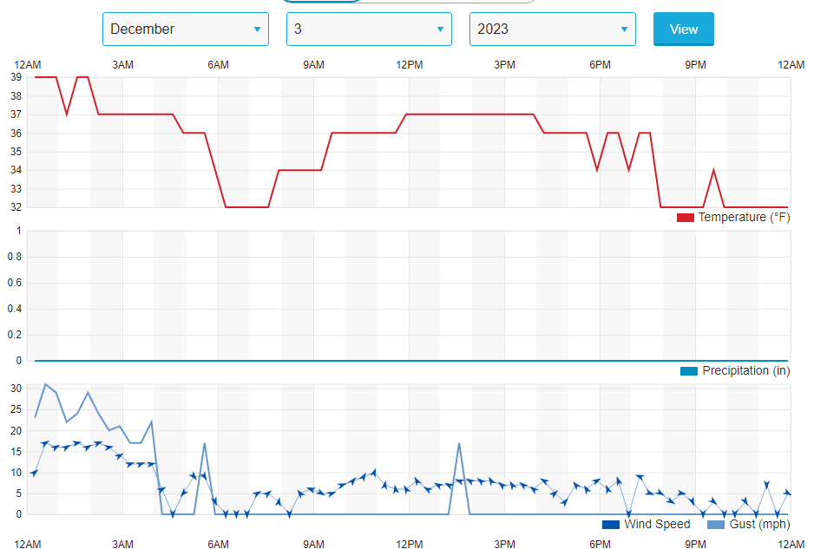

Figure 5: Historical weather data in Boulder, Colorado on the 3rd of December, 2023.

Photographic Choices
Because the submission for the clouds second is a video, and Figure 1 is only the thumbnail, I did ot perform any editing on any of the still frames. However, to get a nice quality time lapse took several tries. I ended up using the GoPro HERO9 black for its accessibility to me through the university library and its multitude of time warp settings. This video¹ was taken with the normal time lapse setting, with the lighting set to ‘outdoors’. I had originally wanted to catch the lighting of the sky in transition, at dawn or dusk, as I thought it to be more artistically pleasing. This however did not turn out how I expected, but I am pleased with the stationary clouds that I captured instead.
The time lapse was set up for about an hour and had condensed to 4 minutes of video. In post processing I cut the first half of the video to the 2:15 mark and also trimmed the end. I then took the remaining 2 minute video and sped it up so that it was easier to watch in our classroom setting.

Conclusion
In this assignment, Clouds First, I submitted to the Flow Visualization archive what I found to be interesting layered formations of moisture in the sky. The photograph that I submitted was taken on the 14th of October with my IPhone X while facing West toward the mountain range. After analyzing the atmosphere on this day, it was easier to deduce the cloud formations seen in this frame. It can be concluded that the warm front moving into town caused atmospheric instability, which gave the conditions for the cumulus and altostratus clouds that were seen at varying heights in this photograph.

References

¹Flow visualization - Cloud Second. (n.d.). Www.youtube.com. Retrieved December 17, 2023, from https://youtu.be/YGRjmjuaCdA?si=eNu92ul6dy1HGIfb
²“Boulder, CO Weather History | Weather Underground.” Www.wunderground.com, www.wunderground.com/history/daily/us/co/boulder/KBDU/date/2023-12-3. Accessed 17 Dec. 2023.
³Met Office. “Lenticular Clouds.” Met Office, www.metoffice.gov.uk/weather/learn-about/weather/types-of-weather/clouds/other-clouds/lenticular.

