Team Second Report
MCEN 4151: Flow Visualization
Riley Menke
11/10/23

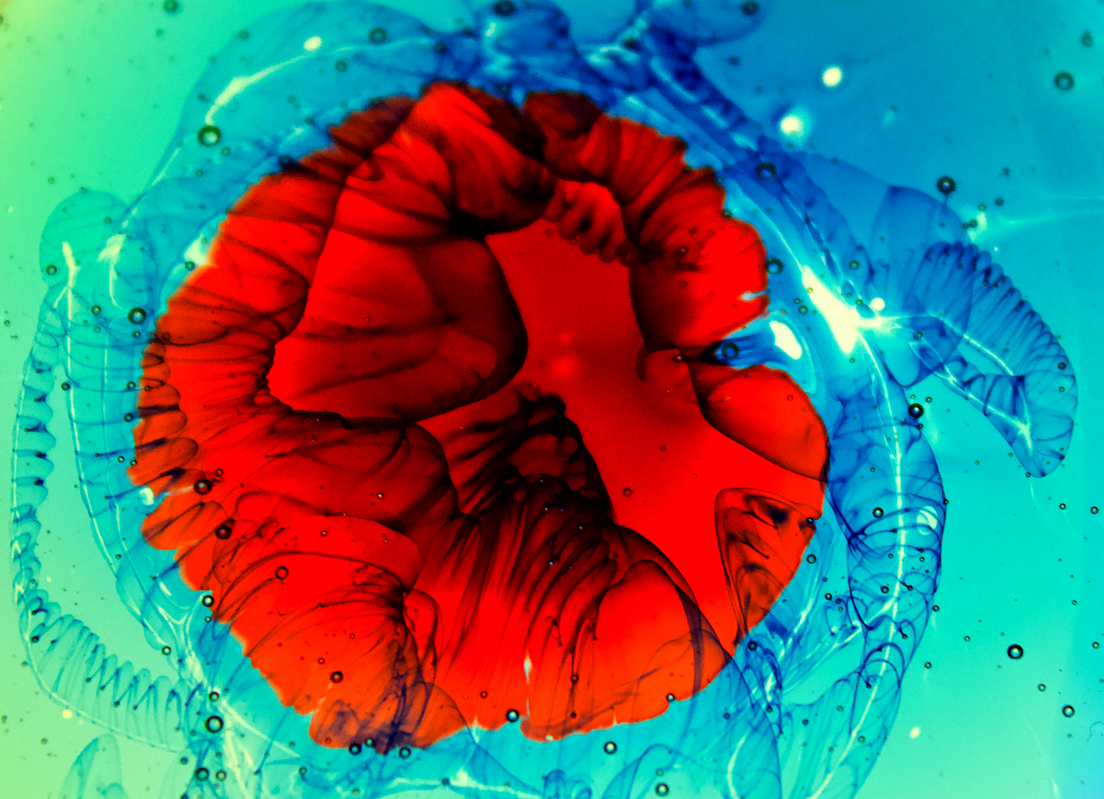Figure 1. Photo of dyed layers of honey in a petri dish, backlit by a white light table. Photographed by Riley Menke, assisted by Tandralee Chetia and Racheal Marbaker.

Introduction
For this assignment in MCEN 4151 at the University of Colorado Boulder, our team had originally set out to photograph the liquid rope coiling effect in action. Given the photography set up we made available to ourselves, catching this phenomena in action proved harder than we anticipated. Furthering our experiment, we added food dye and the creativity took over, resulting in the burst of colors that can be seen in Figure 1. I submit the picture seen in Figure 1 as it still showcases the coiling effect, but the visual has been frozen in time and highlighted by the concentration of blue food dye. This paper will outline why the coils may look like that, and our team's procedure, and my personal photographic editing choices.

Flow Phenomena
In Figure 1, the flow interest lies in the dark blue string-like structures that lie behind the surface of the honey. To visually break this down, we must assume that the liquid rope coiling effect has settled into these shapes as there is no other flow phenome at work here that would produce such geometry in the dye. Figure 2¹ is a helpful schematic that defines all fluid variables that are relevant to the coiling effect and permits discussion of the coiling frequency 𝜔. As shown, Q is the mass flow rate of the viscous liquid involved, and 𝜌, 𝜈, and 𝛾 are the density, the kinematic viscosity, and surface tension coefficient of the fluid respectively. The measurements that need to be considered are the tail and coil lengths of the liquid pour, which compound to the system's overall height, H. In addition, the radius of the tail is a_0, while the radius of the coil is a_1. The overall radius of the system is R, which in this case is controlled by the rigid honey container spout from which the liquid is poured from.
Within the study of the coiling effect of viscous fluids, there are three main theoretical modes by which the coil frequency can be described. By studying the patterns left in dyed honey seen in Figure 1, and understanding the process that resulted in this picture, the variables acting on coil frequency can be deduced. To begin, the first mathematical description of this phenomenon is the Viscous Flow Regime² which is described by Equation 1.
$\frac{Q}{H{a_{1}}^{2}}=Ω_{V}$ | Eq.1
This equation is used in cases where H ﹤0.7cm, where the inertial and gravitational forces on the flow are negligible². The following frequency in Equation 2 occurs when 1cm ≤ H ≤ 5cm and is denoted as governing the Gravitational Flow Regime².
$(\frac{{gQ}^{3}}{ν{a_{1}}^{8}})^{1/4}=Ω_{G}$ | Eq.2

As the height variable progresses to H ≥ 18cm the flow enters the Inertial Regime², which is governed by Equation 3.

$(\frac{Q^{4}}{ν{a_{1}}^{10}})^{1/3}=Ω_{G}$ | Eq.2
There is a fourth regime when 7cm ≤ H ≤ 15cm that holds a bit of mystery because its coiling behavior is not steady as compared to these other three. This function is less important to outline in variables because for our purpose, all that matters is to know that the frequency of the resulting coils fluctuates such that sometimes it makes figure eights and not circles. Because of these distinct visual characteristics, this effect is easily seen in the Figure 1 photo and does not need to be described on such a low level.
The height variable, which determines the governing equations of this flow phenomenon is discussed further in the experimental set-up.

Experimental Setup
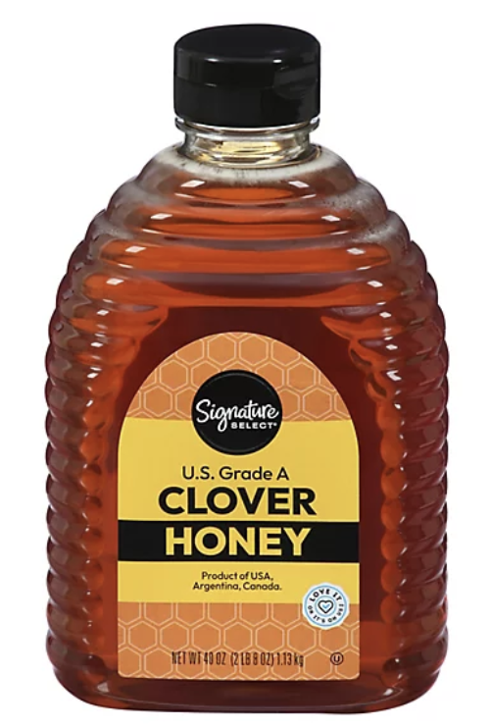
To get the desired results required a small ensemble of household items. The materials list and procedure for the image in Fig.1 is as below.

Materials
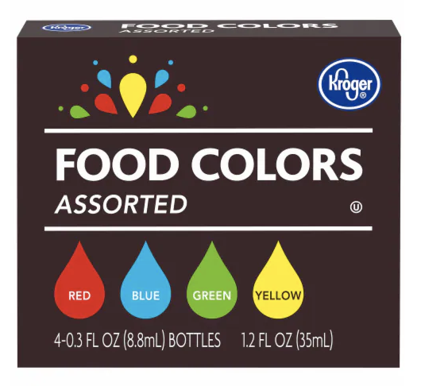
- NXENTC A4 Tracing Light Pad, Ultra-Thin Tracing Light Box USB Powered
- 8cm Diameter Petri dish
- Kroger® Assorted Food Coloring Kit
- Signature Select Honey Clover Squeeze Bottle - 40 Oz

Procedure
To begin, my team of Tandralee Chetia, Racheal Marbaker, and I were pouring honey into just about any container. When we finally recognized the flow phenomena we wanted to capture, the coiling behavior, we set up the petri dish on the light pad and turned off all other lighting sources.
For the experiment captured in Figure 1, we poured a honey, about as much as the diameter of two quarters, and added a drop of blue food coloring immediately after stopping the honey pour. As the viscous fluid spread out under its own weight in the petri dish, it spread the blue coloring radially across its surface.
Using the blue food coloring as a seed for the next layer of honey, we poured the second layer of honey, holding it at least 20 cm above the petri dish, making sure that the coiling was in effect.. This height was mainly to keep the pour out of the camera's lens as we were unaware of the height's effect on coiling. The live action of the fluid's behavior became frozen in the first layer of honey’s viscosity, outlined by the blue seeding.
For artistic effect, we added a contrasting red dye as a fourth layer of fluid. The entire process of this fluid layering is represented in Figure 3.
Figure 3: Representation of the experimental set up, consisting of 4 layers of fluid as outlined in the procedure.

Reflecting back on the theory discussed above, the height of the honey container indicates that the main coiling frequency captured here would be in the Inertial Regime. Looking closely at Figure 4 and its callouts, it is visually apparent where the frequency increases and where the strange properties may have taken over. Similar to the way the blue food dye was stretched and distributed across the surface as the honey pool expanded, the same happened to the coils that were captured in the blue dye. The red layer of food dye best visualizes how the fluid has expanded and stretched the interesting features in the coils, making for an eye catching blossom effect.
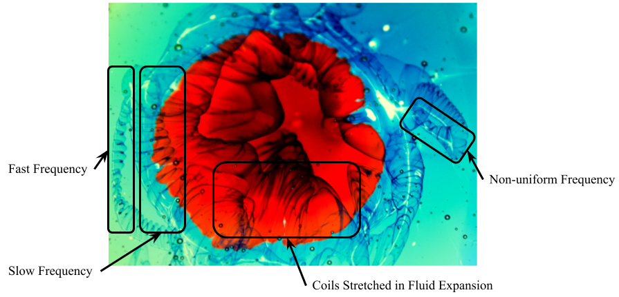
Figure 4: Visual annotation of the coils frequencies and equations that can be seen in the edited photograph.

Photographic Decisions
Using Tandralee’s Canon Rebel T3i 600D 18.MP Digital SLR Camera with an 18-55 mm zoom lens I snapped the photo that is on the left-hand side of Figure 5. As briefly mentioned before, the only source of lighting for this image comes from behind the subject. This light pad illuminates the honey in a striking way that appears to make all of the layers glow.
In editing, I cropped the image from the raw 5184 x 3456 pixels to about 2911 x 2108 to focus on the coils and the interesting dye interactions. In addition to the crop, I used my Mac Preview application to make the following edits. I increased the saturation of the image greatly and slightly increased the contrast. This made the image’s brights nearly burst and the darks sink into the edges of the coils. In addition, I adjusted the color hues so that the blues in the image take up a larger portion of the pixels. These choices are what I believe made the image really pop. In the end I really enjoy the organic flower shape that emerges in the red dye overlapping all the underlying lines.
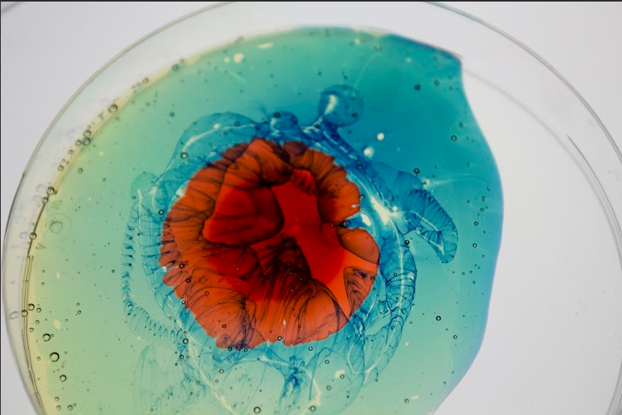
Figure 5: Shows how editing choices create differences in the original and submitted image. The left is the unedited image, and the right is the image that has been edited and submitted to the archive.

Conclusion
The image presented in Figure 1 freezes in time the fascinating effects of viscous fluid coiling while presenting itself merely as a bright bloom of aesthetic. Progressing in my own photography skills, I believe that this picture is one of my more expressive submissions. The unconventional mode of capturing this phenomena in its own medium was unique in comparison to our other attempts of photographing viscous coiling. Because of this method, the single photograph in Figure 1 was able to visually characterize the Inertial and Gravitational coiling flow regimes as well as the instability in the middle. I believe it is this novelty in visualizing flow physics and the artistic choices made in editing that makes this photo submission so striking.

References
¹Ribe, Neil M. “Liquid rope coiling: A Synoptic View.” Journal of Fluid Mechanics, vol. 812, 2016, https://doi.org/10.1017/jfm.2016.836.
²N. M. Ribe, M. Habibi, Daniel Bonn. Stability of Liquid Rope Coiling. Physics of Fluids, 2006, 18, pp.268-279. hal-00129393

