Team Third

Riley Menke

MCEN4151: Flow Visualization

12/06/23

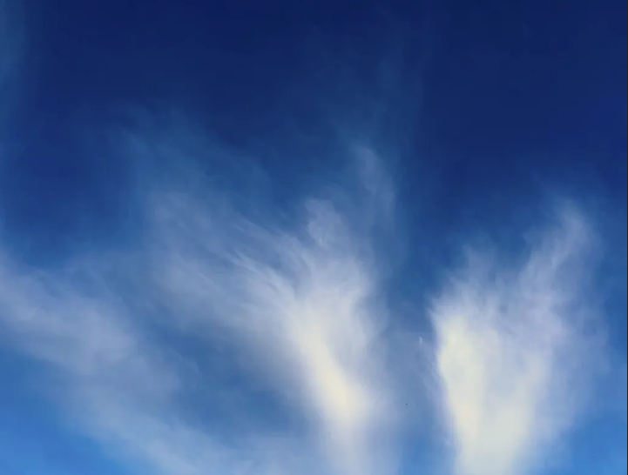

Background
For the third team assignment, I ended up taking a photo of flow on my own after the original plan did not pan out in the way that we expected it to. Our original intention was to try and capture Von Karman vortices, ideally in a thin channel. To do this, we tried to capture this phenomena by means of a seeded fluid displaying the vorticity shape. In attempting to do this before the weeklong Thanksgiving break, the team soon found out that with the current equipment, a quality photo would not have been achievable.

To compensate for the lack of flow visualized for this third assignment, I photographed Cirrus Uncinus clouds that caught my eye while climbing the Sanitas mountains. The picture was taken on the 19th of November around 3:30 in the afternoon. What inspired me to capture this moment of flow in the atmosphere was the distinct lines between the streams of moisture. Below in this report, the skew-T graphs will show that the dewpoint and temperature lines are close across a majority of the isobar lines.

Flow Classification
As briefly discussed in the introduction, the clouds in this photograph are most likely Cirrus Uncinus at the advice of Dr. Hertzberg. From the top of Sanitas, right below the cloud structure, the usual distinctive features of this cloud classification take on an interesting shape. Usually these clouds are characterized by a hook shape, followed by the classic Cirrus whisps. As seen from below, these features are harder to identify but have been outlined in Figure 1.
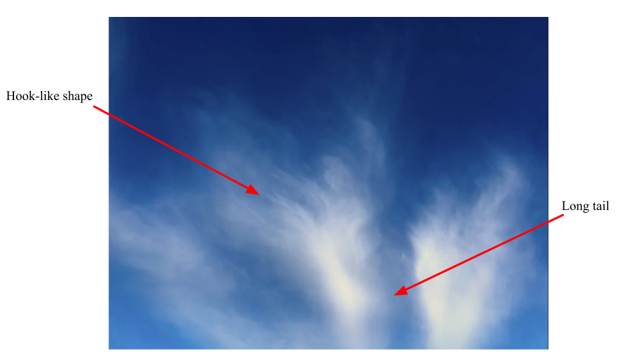
Figure 1: Identifying the Cirrus Uncinus cloud formation visible in the frame

Primarily, the Cirrus Uncinus cloud forms when a cold front moves in below the current hot air and pushes the clouds farther up into the atmosphere. Per the knowledge of Dr. Hertberg, the Uncinus aspect of these clouds, the ‘hook’, comes from the frozen particulates that occur at this high altitude. As the air rushes around in the atmosphere, it drags the seeding of the flow across the sky, which we the viewer see as the wispy Cirrus cloud.

Skew-T
To further analyze these formations in the Boulder sky at 3:30pm on the 19th of November, I used the Skew-T graphs seen in figures 2 and 3. These were taken from the Salt Lake city weather station from the morning and evening readings on the 19th.
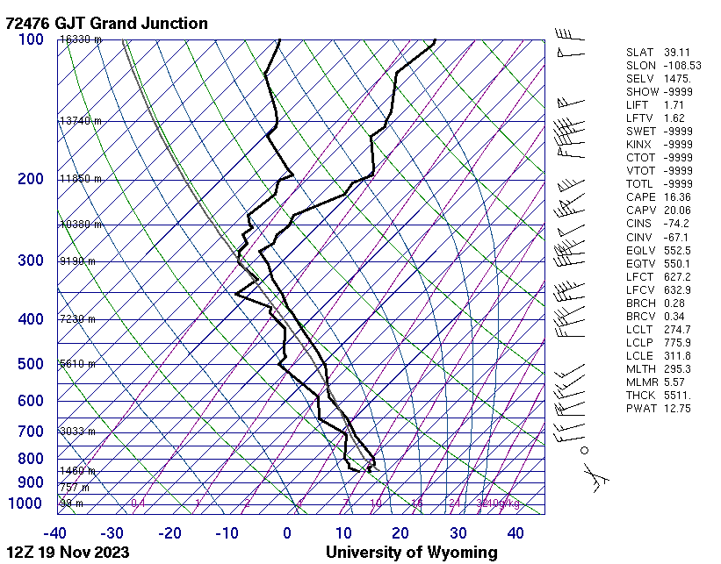
Figure 2: Skew-T graph taken from the SLC station at 7am on November 19th, 2023
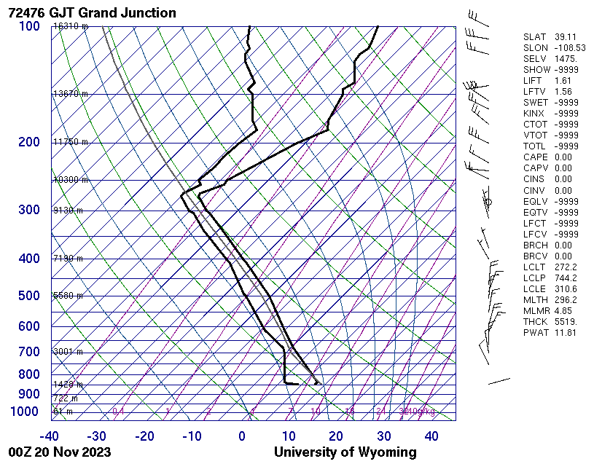
Figure 3: The Skew-T graph from 7pm on November 19th, 2023

Looking at these graphs, it is clear that the temperature of the atmosphere only gets colder as we follow an imaginary parcel of air up to lower pressure. Looking at historical weather data, the dates preceding the 19th, are consistent of 50℉ temperatures. This would explain how the moist adiabat line to the left of the temperature line is nearly parallel in slope on both graphs. The close proximity of both the temperature and dewpoint lines indicate that the day was very likely for cloud formation. The day after the 19th, the temperature dropped 10℉, giving confirmation that there was indeed a cold front pushing the parcels high into the atmosphere to give the Cirrus Uncinus clouds that are seen in the submitted photo. The historical weather data is seen in sequential charts below that make up figure 4.

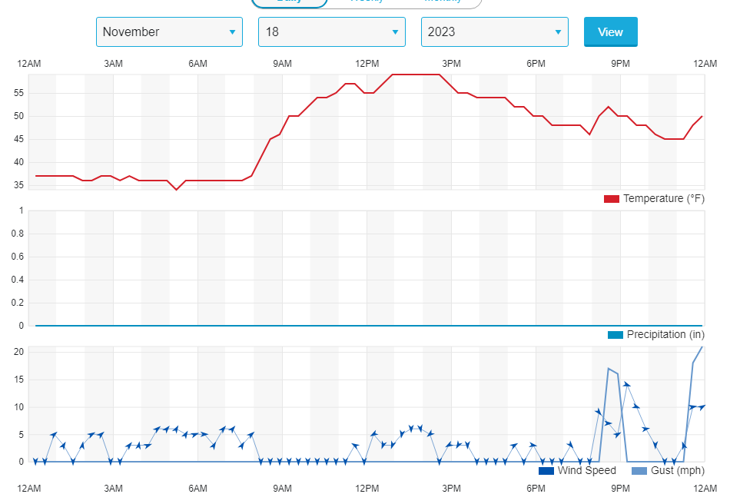
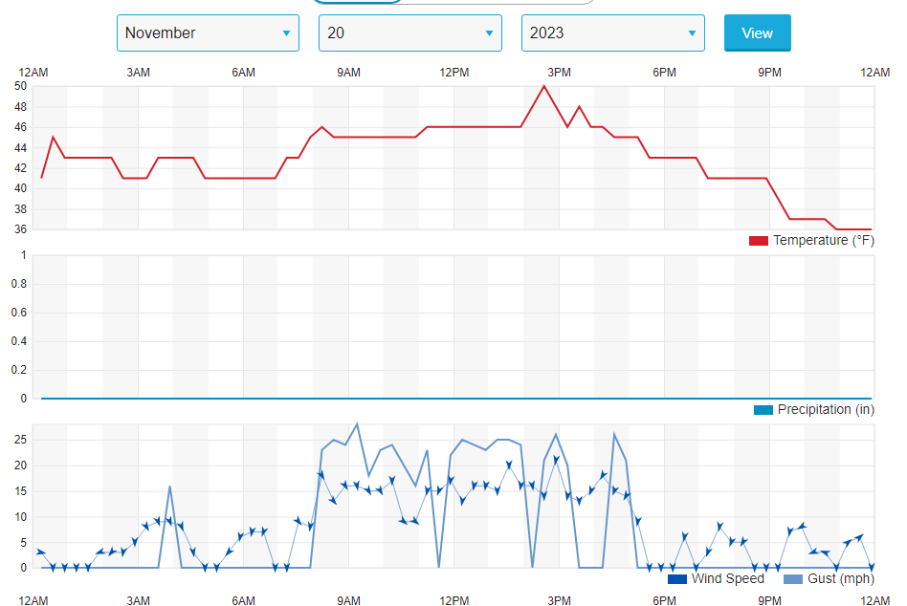
Figure 4: Historical weather data in Boulder, COlorado on the 18th and 20th of November, 2023

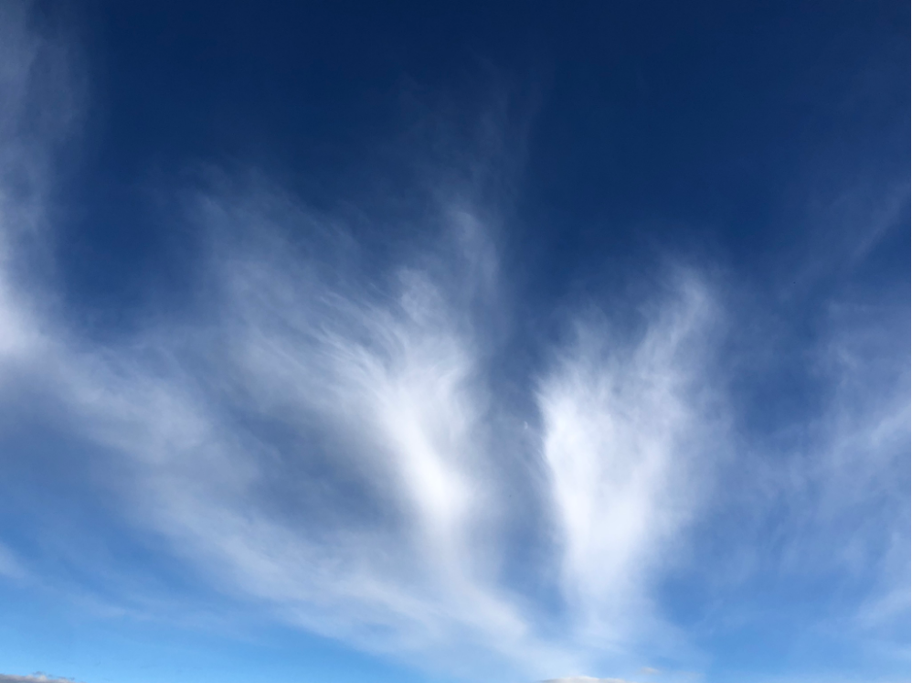
Photography Choices

Figure 5: Unedited photo on the left and the edited and submitted photo on the right

In an artistic effort to accentuate the visualized flow in the atmosphere, I made a few edits to the original picture that can be seen on the left of figure 5. These edits include barely increasing the saturation, and slightly increasing the contrast so that the blue is much more stark behind the clouds. I also cropped the frame of the photo, decreasing its dimensions from 4032x3024 pixels to 3073x2324 pixels. In addition to reducing the size, I wanted to frame the clouds that are in the top of the original photo. This way, the clouds look like they are streaming or even draining off the page in my personal artistic opinion. By editing the photo to get the result on the right hand side of Figure 5, I was able to accentuate the atmospheric flow visualized by the Cirrus Uncinus clouds, while still maintaining what I wanted to get out of this series of photography.

Conclusion
For the purpose of the third assignment, I decided to present the flow in Cirrus Uncinus clouds rather than the original idea which included vortices. In the end, the flow visualized, describes an incoming cold front and the little change in skew-T graphs indicates that there were many parcels of moisture to seed the air on November 19th. ALthough there was minimal editing done to the original photograph, the artistic choices made were done to both draw attention to the flow and to acknowledge the beauty in the atmospheric motion. Capturing Cirrus Uncinus clouds is slightly less common, and to view the flow from this angle makes for an interesting perception of atmospheric flow.

Works Cited

“Boulder, CO Weather History | Weather Underground.” Www.wunderground.com, www.wunderground.com/history/daily/us/co/boulder/KBDU. Accessed 7 Dec. 2023.
“Cirrus Uncinus Clouds.” WINDY.APP, windy.app/textbook/cirrus-uncinus-clouds.html#:~:text=Cirrus%20uncinus%20clouds%20are%20formed. Accessed 7 Dec. 2023.
“Learn about Cirrus Uncinus Clouds: Curved, Comma-Shaped.” Whatsthiscloud, whatsthiscloud.com/cloud-species/uncinus/. Accessed 7 Dec. 2023.

