Light Flow through Fog
12/3/2023
By Stella Meillon
Co-Authors: Leo Steinbarth, Austin Sommars, Greg Kornguth
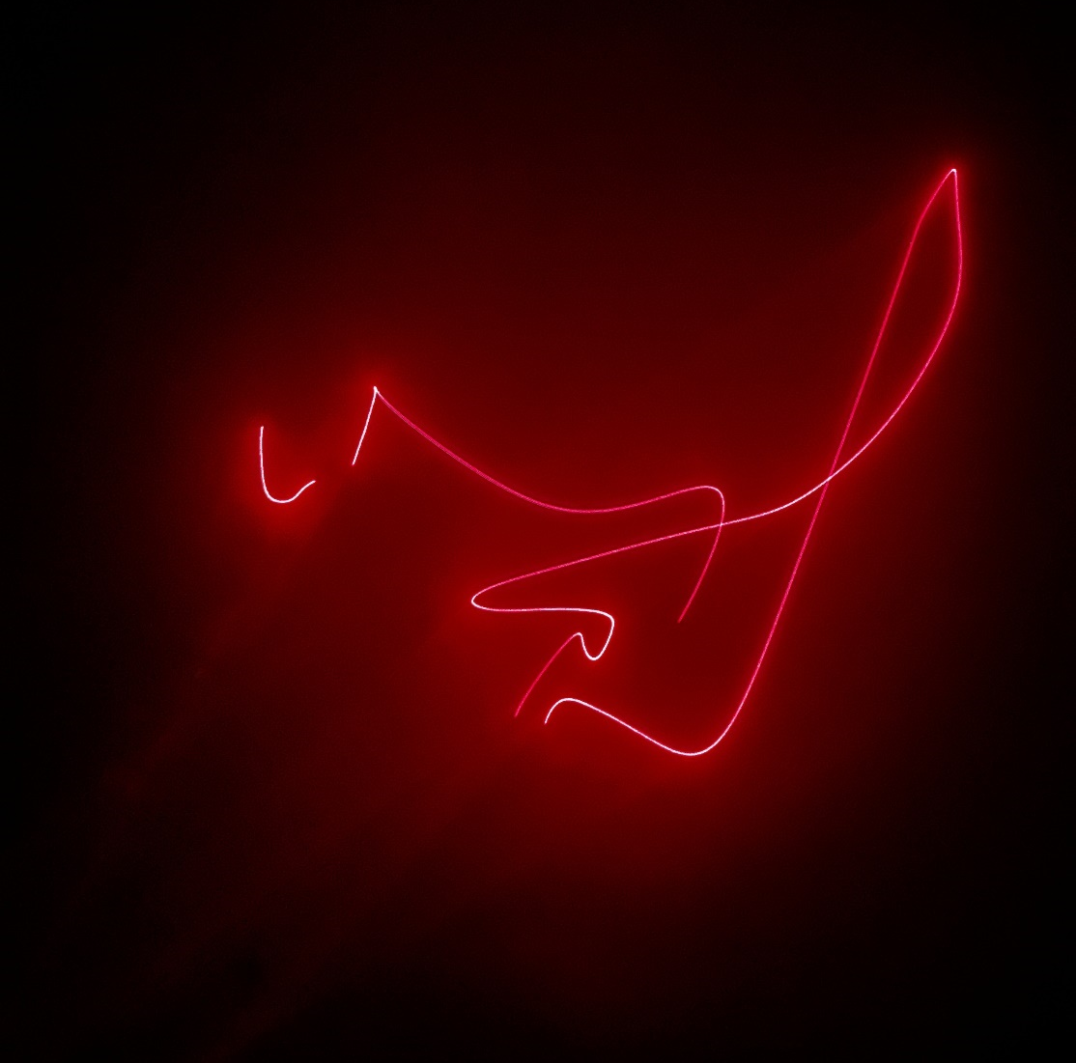

Context and Purpose
When deciding what to do for the third team assignment, we decided to look at laser light through a glass dowel projected onto fog. The fog helps disperse the light particles and create a more impressive visual, so we wanted to see how it would look through a dowel. Our system setup included a glass dowel, a powerful laser, and a fog machine, and the photos were taken in a dark room at Leo Steinbarth’s house.
Flow Description and Visualization Technique
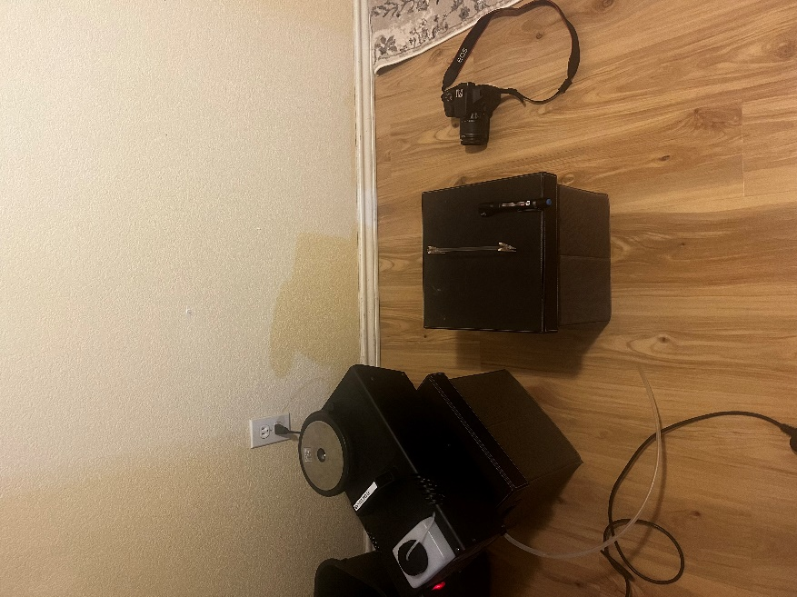
To create the image, we setup a glass dowel on a box and shone the red laser at the dowel in different positions. This created a variety of patterns and effects depending on where we shone the laser. The image I took above was with the laser pointed into the side of the dowel, thus causing the light to bounce off the inside walls of the dowel and create a pattern on the wall. Shifting the laser around the dowel produced different geometries, angles, and patterns, which each were distorted in different ways by the fog. The light particles dispersed through the fog and thus the main light flow was not as bright as if there had been no fog. Some of these patterns were much more visually captivating than others, so as a team we prioritized working on those angles
Photo Technique
To take this photo took a bit of experimentation with the lens and camera settings. For this photo the settings were as follows: Shutter Speed was , aperture was , ISO was , and focal length was .
Analysis

