Mica in Oil
By Stella Meillon
Flow Visualization F23 Section 001
11/10/2023

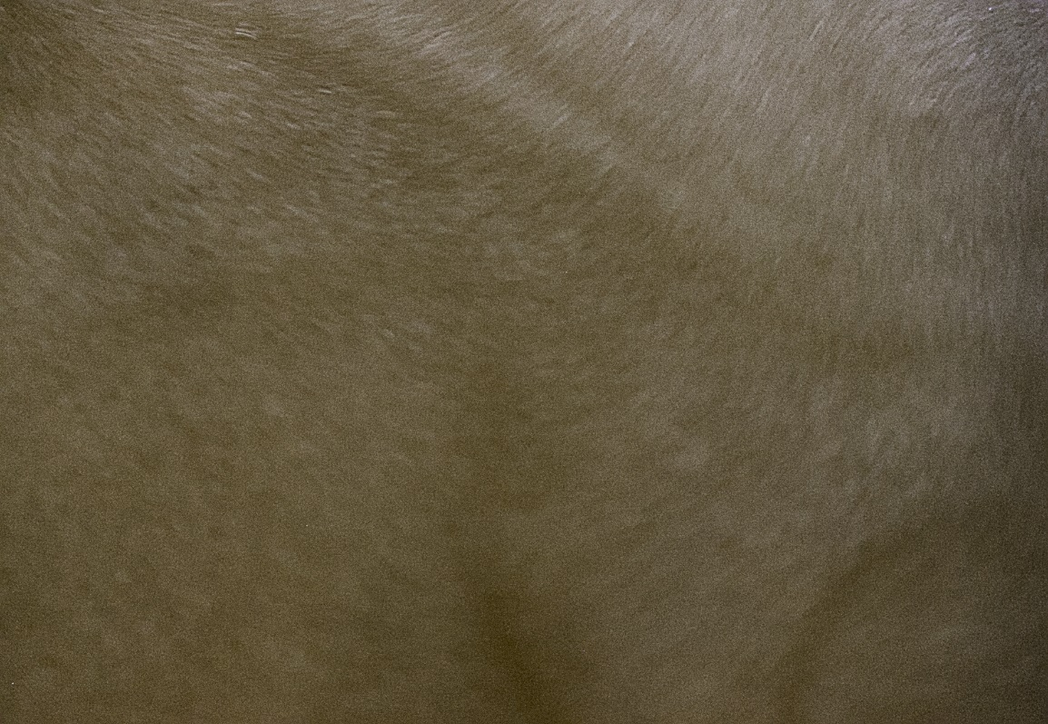

Context and Purpose
The purpose of this lab was to study the Rayleigh Bernard convection, during which a hot fluid interacts with less dense particle matter and creates a bubbling effect wherein the materials flow through each other. Our system setup included canola oil and mica powder mixed in a metallic oven dish, which was then placed atop a hot plate at 200 degrees Fahrenheit. Unfortunately, the canola oil was too dense for the experiment, and we were unable to observe the Rayleigh Bernard convection cells. Instead, I took photographs of the substance and was able to see the flowing patterns of the agitated mica powder. The team for this experiment consisted of myself, Austin Sommars, Greg Kornguth, and Leo Steinbarth.

Flow Description
The depicted image is the turbulent flow of heated oil with mica powder mixed into it.
Oil and mica powder
Hot Plate
The turbulence was caused by arbitrarily stirring a rod through the mixture, leading to random patterns through the fluid. The movement of the flow is determined by the viscosity of the oil and the amount of mica powder mixed in. The viscosity of the oil determines how long the agitation will persist, while the density of the mica powder determines how long it will stay suspended in the fluid until it sinks back to the surface of the plate. We poured in 3 cups of vegetable oil and half of a tube of mica powder to create the mixture, then heated it to 200 degrees Fahrenheit.
However, the desired flow visualization consisting of Rayleigh Bernard convection cells was not achieved. We were told that using vegetable oil to substitute for silicon oil would work but it was too viscous and thus did not properly demonstrate the technique. The achieved turbulence cannot be mathematically modeled via a set equation, although the actual agitation should not have the strongest impact on the model because to recreate a similar image, any swirling agitation would suffice.
Visualization Technique
To photograph the image, I stood atop the counter upon which the setup was placed and took the image from above. We turned off the direct lighting on the system and used flashlights to intentionally direct light towards the system. The other lighting on the system was ambient within the basement of the ITLL in the engineering center, so it was indirect lighting.
Photo Technique
The final resolution of the image was 1883x1300 pixels, and the original was 5202x3604. To take the photo, I used a Canon EOS 550D camera with ISO speed of 3200, F-stop of f/5.6, exposure time of 1/30 seconds, focal length of 250 mm, and exposure bias of 0 step. To edit the photo, I used Darktable and reduced the exposure, increased the sharpness to bring more attention to the mica grains, and darkened the color profile to increase the contrast. The original image is as follows:
Analysis
The final image displays the flowing patterns of mica in the vegetable oil. I like that there are different layers to the flow, with main patterns being followed by the powder. It closely resembles wavy fabric or velvet, and it’s interesting to learn that it is actually fluid motion that, when paused in time, looks like a solid and versatile object. Despite our flow not working as desired, I did enjoy this final image and was overall content with how it turned out. Going back, I would do more research into the system setup and make sure we allocated enough planning and time to acquire silicon oil and properly demonstrate the Rayleigh Bernard convection cells.

