Flow Visualization Report:
Violet and Black Mica Powder Swirl in Water
Caidan Caswell
Flow Visualization:Team First
MCEN 4151 - Fall 2024
October 1, 2024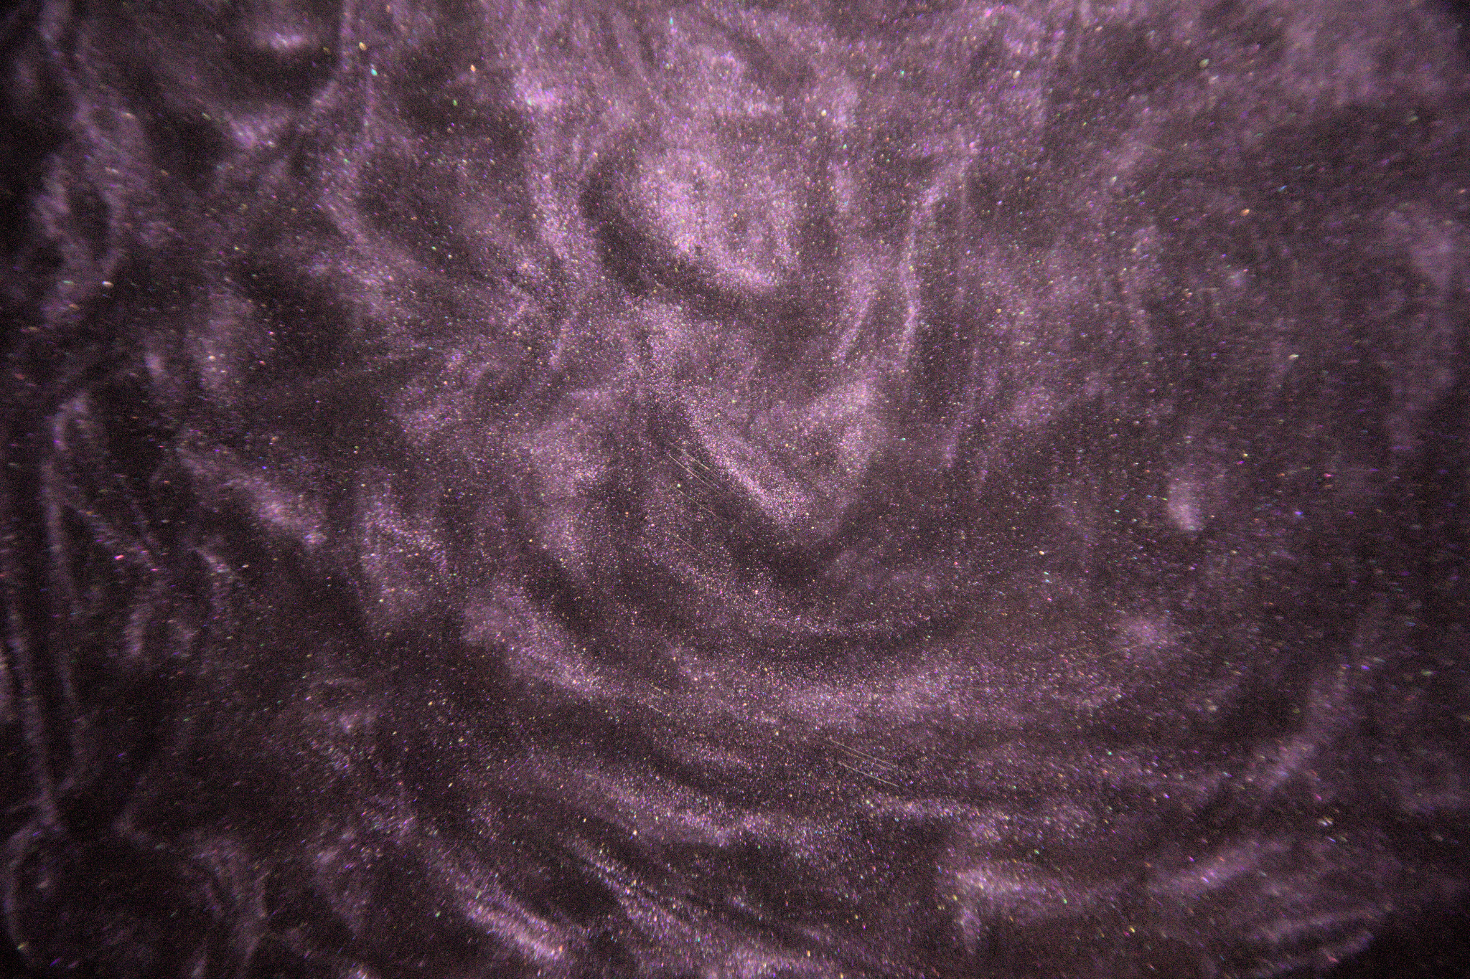
Introduction
This report documents a flow visualization experiment aimed at capturing the swirling interactions of violet and black mica powder in water. The goal was to explore fluid flow behavior, particularly the transition from laminar to turbulent flow, particle dispersion, and vortex formation. This project was part of a broader study on fluid dynamics, with an emphasis on visualizing how suspended particles behave under fluid motion. The experiment was conducted colloboartively, with my team member collaborating on assisting with the setup and execution.
Flow Apparatus
The experiment was carried out using a 2x1x0.25 ft acrylic box filled with water, serving as the controlled environment for the flow. The box was placed on a flat surface, and the camera was positioned 12 inches away from the front to capture the scene from a lateral perspective. Two lamps were directed at the water’s surface to ensure consistent lighting, and a piece of vinyl sheet was placed behind the tank to eliminate background distractions and enhance contrast.
The mica powders were introduced at the surface of the water, and a gentle stirring motion was applied to initiate flow. The motion generated a combination of laminar and turbulent flows as the powders dispersed throughout the water. The scale of the flow was approximately 24 inches across the length of the tank, with flow velocities on the order of 0.1 m/s.
Flow Physics:
In terms of flow physics, the experiment captured two key flow regimes: laminar flow and turbulent flow. Initially, the motion was characterized by smooth laminar flow as the mica powders followed the gentle stirring motion. As the stirring intensified, the flow became turbulent, producing eddies and vortex structures.
To quantify the flow, we can estimate the Reynolds number (Re), a dimensionless quantity that characterizes the flow regime:
$Re=\frac{UL}{ν}$​
where:
- U is the characteristic velocity of the flow, approximately 0.1 m/s
- L is the characteristic length, taken as the width of the box (0.6 m)
- $υ$is the kinematic viscosity of water, $1.004X10^{-6}m^{2}/s$
$Re=\frac{(0.1m/s)(0,6m)}{1.004X10^{-6}m^{2}/s}≈60000$
A Reynolds number of approximately 60,000 suggests that the flow is firmly in the turbulent regime, consistent with the observations of swirling eddies and chaotic mixing of the powders. The black mica, due to its higher density, settled faster than the violet mica, highlighting gravitational settling effects.
Visualization Technique:
The visualization technique involved introducing violet and black mica powder to the water surface. Mica powder was chosen due to its reflective and vibrant properties, which made the flow patterns visually striking. The powders were sprinkled evenly across the surface of the water to ensure clear flow visualization.
Environmental conditions were controlled, with minimal external airflow to prevent disturbances. The room was kept at ambient temperature, and no significant environmental factors affected the behavior of the fluid.
Two lamps were positioned at the sides of the tank, casting light onto the water surface. This lighting setup minimized shadows and reflections, while the black vinyl backdrop enhanced the visibility of the swirling mica powders.
Photographic Technique:
The images were captured using a Canon EOS 6D Mark II with an EF 28-135mm f/3.5-5.6 IS lens. The following camera settings were used:
- Aperture: f/5.6
- Shutter Speed: 1/500 s
- ISO: 800
- Focal Length: 28mm
- Distance from Object: 12 inches
The field of view covered the entire length of the acrylic box (approximately 24 inches). These settings were chosen to balance light sensitivity (ISO 800) with fast shutter speed (1/500 s) to capture crisp images of the fast-moving particles. No significant image processing was performed, except for minor adjustments to brightness and contrast in post-processing to emphasize the contrast between the powders and the water.
Analysis and Discussion:
The final images effectively reveal the fluid dynamics of the swirling mica powders. The violet mica traced the upper layers of flow, remaining suspended longer, while the denser black mica settled faster, creating a layered effect. The large-scale vortices visible in the turbulent regime demonstrate the chaotic nature of the flow, with smaller eddies forming and dissipating throughout the process.
What I appreciate about the images is the clarity with which the transition from laminar to turbulent flow is captured. The swirling interactions of the powders vividly demonstrate the complexity of turbulent flows, as well as the effects of gravity on particulate motion. However, one aspect I would improve is the evenness of the lighting. Despite efforts to reduce glare, minor reflections on the water surface were still present.
In future experiments, I would consider using a more diffuse lighting setup to eliminate reflections entirely. Additionally, exploring different types of powders or particle sizes could offer further insights into how particulate density affects flow patterns.

Conclusion:
This experiment successfully visualized the interplay between laminar and turbulent flow in a confined water medium using mica powder as tracers. The controlled setup and choice of contrasting powders highlighted key fluid dynamics principles, including vortex formation, particle dispersion, and settling. With improvements to lighting and perhaps alternative particle materials, the visualization could be further refined for future explorations in flow dynamics.
References:
- Van Dyke, M. (1982). An Album of Fluid Motion. Parabolic Press.
- Settles, G. (2001). Schlieren and Shadowgraph Techniques. Springer-Verlag.
- Hertzberg, J., & Potter, M. (2020). The Art of Flow Visualization. In Art & Science of Flow.

