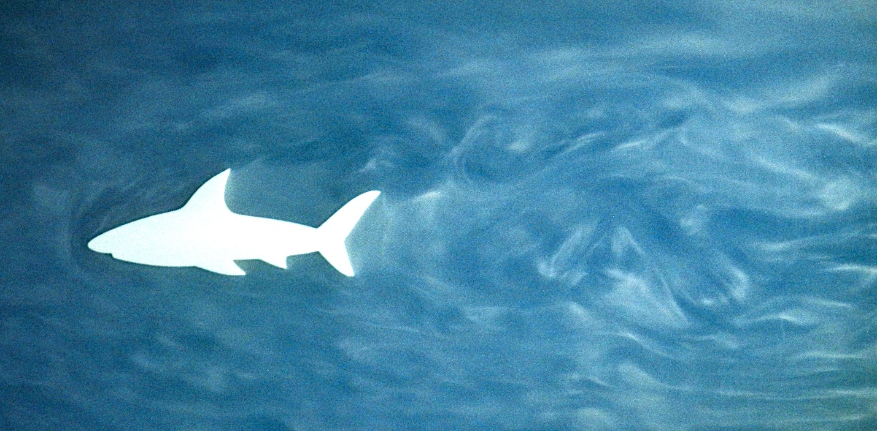

**Team 1 Report: Shark Wake**

Kate French

10/7/2024

Flow Visualization Fall 2024

Contributions from: Sarah Hastings and Lia Cucuzzella

**Introduction:**

In my fluid mechanics course, I was given free rein to complete a research project on a fluid-related topic of my choice. My project partner and I originally wanted to investigate whirlpools – but preliminary research demonstrated that, while a good deal is known about vortices in, say, bottles, bathtubs, and other drain-based scenarios, shockingly little academic research has been conducted on whirlpools “in the wild.” This, we speculated, was due to the challenging logistics of approaching a whirlpool to study it: getting near enough to study the fluid phenomena present would, without the aid of drones or a helicopter, require placing oneself at the mercy of the furious downspout. Surprisingly, academics do not all feel compelled to put themselves in that scenario.

Thus, due to a dearth of adequate academic sources, my partner and I pivoted: instead of whirlpools, we decided, we would study tornados. Many of their physics align with what is speculated about whirlpools, but, because they are made of air, rather than water, one need not begin directly on top of them in order to study them. When brainstorming which particular element(s) of tornadoes to focus on, we remembered about the pop culture hilarity that is the *Sharknado* franchise, which got us thinking… As it turns out, Sharknado is extremely researchable: NOAA has performed a good deal of research on tornadoes (primarily for human safety reasons), while NASA and other aerospace organizations have been pursuing technology mimicking the characteristics of ocean creatures, which requires studying the fluid dynamics surrounding different marine animals, including sharks. Over the course of the next several weeks, I came to understand that Sharknado is not especially feasible, due to the high mass-to-surface-area ratio of sharks, which reduces their drag when swimming, but also reduces their lift in tornado situations.

I was reminded of this amusing project while discussing potential flows to visualize for this course. Sarah was interested in documenting the von Carmen vortex street behind circular forms in laminar flow, or in visualizing the flow around an airfoil. I, meanwhile, recalled my glory days of Sharknado research and leaped upon this opportunity to gain a deeper understanding of the flow of fluid around a shark. My goal was to see the flow around and behind a great white shark, as the most stereotypical shark present in Sharknado to the best of my knowledge. Given the logistics of the tank set-up, my more realistic mission became to visualize the flow around and behind an airfoil or prism shaped similarly to a cross-section of a great white shark.

**Fluid Mechanics:**

**Figure 1.** Set-Up.

As shown in Figure 1, the set-up consisted of a large glass tank (48x12x18 in) with a black acrylic divider held in place 1.25 inches from the side with two spacers towards the bottom of the tank (dark grey in the schematic) and two clamps (dark teal) at the top of the tank. Swamp cooler foam [insert brand] was used to straighten the flow somewhat and decrease the backflow eddies that were otherwise quite strong. The shark was positioned approximately 20 cm away from the swamp cooler foam strip, and roughly centered in the tank vertically to avoid any boundary layer interactions with the top and bottom of the tank.

**Figure 2**. Shark Outline Used to 3D Print Airfoil, with Characteristic Length Labeled

The shark was a 3D printed prism with a shark-shaped base. The shark outline base was taken from <https://www.vecteezy.com/vector-art/4692524-shark-outline-vector>. It was inserted into coreldraw to do an outline trace (detailed logo mode). This traced outline was exported as a .dxf, which was then loaded into solidworks, extruded to the correct height of 1.25 inches, and 3D printed (20% infill, 0.1 mm layer height) on a prusa mark 4 with polymaker polyterra filament.

The flow was made visible with rheoscopic fluid, a mixture of water and stearic acid crystals from settled shaving cream. Approximately 6 cans of the “smart” brand of shaving cream from Target were used: <https://www.target.com/p/ocean-scented-shaving-foam-10oz-smartly-8482/-/A-75557153#lnk=sametab>. Following the directions found at <https://fyfluiddynamics.com/2018/09/although-you-may-not-recognize-the-name-youve/>, we mixed 1:20 by weight of shaving cream to water and allowed it to settle for at least two hours. We then poured out the fluid underneath, which was a mixture of water and stearic acid crystals. We allowed each bucket of shaving cream fluid to settle several times before pouring out any newly settled rheoscopic fluid.

We stuck the shark in simply via friction; its air voids made it buoyant, but placing the clamps at the top of the tank allowed us to pinch the shark between the tank wall and the acrylic divider, keeping it in place.

Reynolds Number, the dimensionless number describing turbulent vs laminar flow, can be calculated:[1]

(1)

where $v$ is the velocity of the fluid, $L$ is the characteristic length for the geometry, and $ν$ is the kinematic viscosity of the fluid.

In this case, v = 0.04 m/sec (because tracing a particular packet of fluid showed that it moved 14 cm in approximately 3.5 seconds). At 20°C, which was approximately the temperature of the water in the tank, the kinematic viscosity of water is approximately 1x10-6 m2/sec. This kinematic viscosity is also taken at atmospheric pressure; in Boulder, CO, the barometric pressure is slightly lower, but the density of water does not change significantly at that minor of a drop below standard atmospheric pressure, so the kinematic viscosity should be fairly accurate. The rheoscopic crystals suspended in the water may alter the kinematic viscosity somewhat; however, one of the benefits of stearic acid crystals in particular is that their density is comparable to that of water; it is challenging to find information about them increasing the dynamic viscosity of water, so, for the purposes of this analysis, we will assume that the impacts of the crystals on the fluid’s viscosity is negligible in order to get a general order of magnitude estimate of the Reynolds Number. The characteristic length of the shark, which was chosen to mimic the characteristic length used for an airfoil, is labeled in Figure 2 above. Its value was 14 cm (0.14 m). Plugging these values into (1), we get a Reynolds number of 5600. This is above the usual transitional region of 2300 to 4000; thus, we are in turbulent flow.

Dynamics over time []

Vortices?

**Photographic Procedure:**

The original photo was taken with a Nikon COOLPIX P500, a type of compact digital camera. The focal length was 14 mm, and the original picture dimensions were 4000 x 3000 pixels. To avoid any motion blur during the slow shutter speed, the camera was placed on a tripod approximately 40 inches away from the tank at the same height as the shark. The f-stop was f/6.3, the exposure time was 1/5 sec, the ISO was 160, and the max aperture was 3.5. These settings were chosen via experimentation prior to the official photo shoot beginning. Heightening the ISO much more than this caused the image to become fairly grainy; it already had a certain amount of graininess, and this higher graininess became unacceptable.

The lighting used consisted of two headlamps (approximately [] and [] lumens) also held approximately 40 inches away from the shark; the brighter headlamp was held to the right of the camera, and the dimmer one was held to the left. This configuration was chosen to maximize the visibility of the wake of the shark, but it had the consequence of making the stagnation point and shockwaves ahead of the shark marginally less visible. The headlamps were held by hand and adjusted so as to eliminate glare or reflections against the tank glass.

[figure of lighting configuration: need details about lumens and so forth]

The image underwent a relatively extensive set of post-processing steps in Darktable. The initial image can be seen below inFigure 3.

The top of the original image contains one of the two clamps used to hold the tank’s divider in place. This was cropped out, along with the far enough below the shark that was not as obviously dependent on the shark’s presence for its flow patterns. This left final dimensions of 3618 x 1783 pixels. The final field of view was approximately 22.4 x 45.5 cm.

Framing-wise, I aimed to follow the rule of thirds by having the shark centered approximately around the one-third mark from the left side of the image. This allowed the wake swirls to be framed nicely while adding interest due to the breaking the image into thirds.

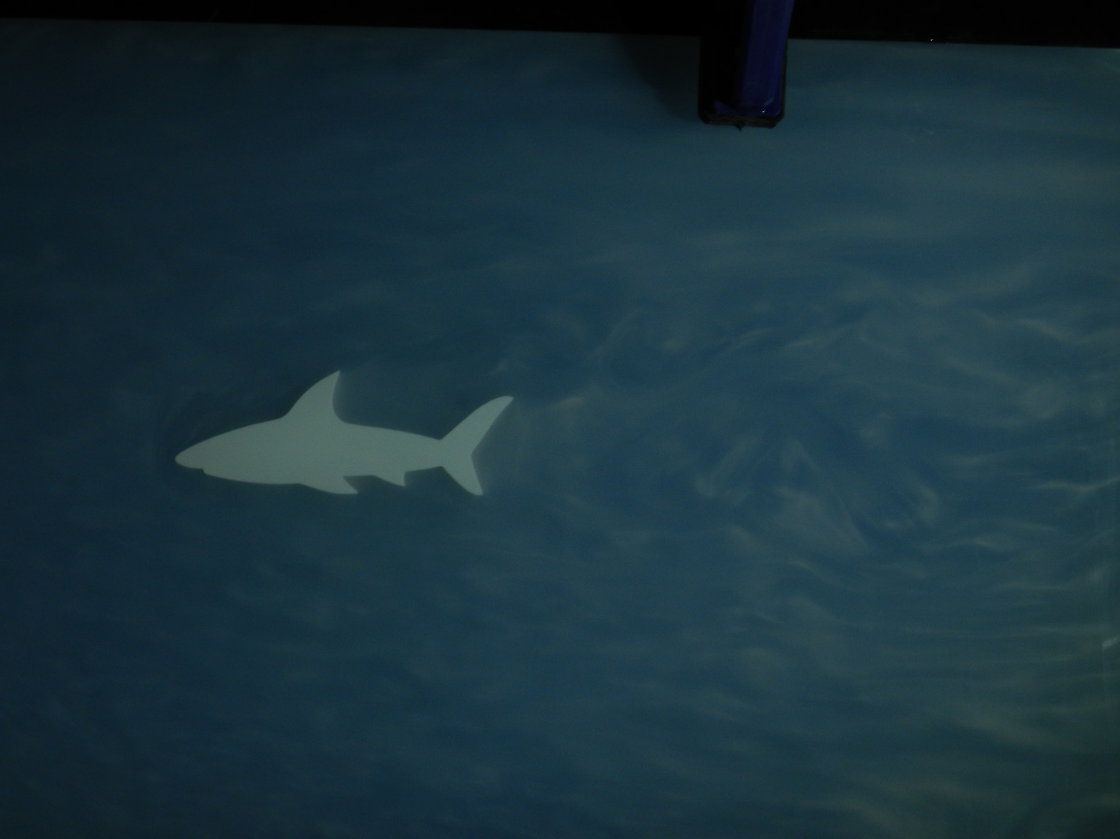

**Figure 3**. Unedited image

The original image was quite dark. I increased the exposure, increased the local contrast (detail 217%, highlights 50%, shadows 50%, midtone range 0.500) and changed the filmic rgb properties to increase the white relative exposure (2.67 EV). These steps had the combined effect of making the image brighter and increasing the contrast – and thereby the visibility of the flow patterns. However, they created a white haze around the shark, which I found distracting in a larger image. While I enjoyed the visibility of the flow in the hazy image, I decided to use haze removal to decrease the white haze around the shark. The effects of the haze removal can be seen below in Figure 4. I feel that the haze removal increased the drama of the piece and made it feel more as though the shark were swimming in the ocean, and it increased the visibility of some of the nuances of the flow close behind the shark.

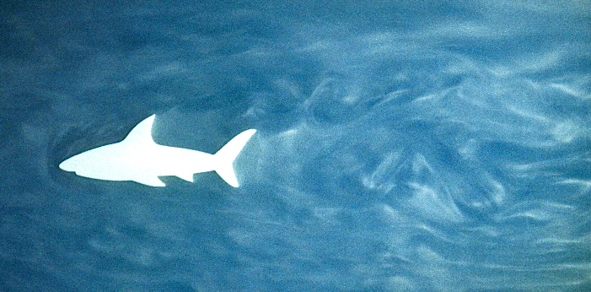

**Figure 4**. Image before (left) and after (right) haze removal in Darktable.

**Conclusion:**

Overall, I am pleased with my image. I feel that it was slightly grainy, which is disappointing, but it does provide a insight into the dynamics around (a cross-section of) a shark swimming in the ocean.

It would be interesting to have a 3D shark, rather than a cross-sectional prism of one. The logistics were much more feasible both for clarity of vision and ability to keep the shark in place for the prism, however.

Subsequent to our team photo shoot, Sarah was able to get the flow much more laminar. I considered redoing my photos with the new, less turbulent flow, but I decided that the mild turbulence was more similar to the environment in which a real shark might swim and, thus, more thematically appropriate. Additionally, I found it to be more beautiful to my particular tastes.

Sarah was also able to acquire more uniform bright light; I considered using it, but I was pleased enough with my existing images. It would be interesting to try it in the other conditions and see the differences.

I also considered taking a video, as the flow patterns were unstable/constantly in flux.

I was fascinated by how the water swirled around the outtake pipe.

I find it slightly disappointing that there are vertical streaks on the right side of the image. These were caused by water dripping down the external surface of the tank’s glass while inserting the shark; we remembered to wipe down the tank between other objects, but evidently not between the previous one and the shark. I considered cropping the image to exclude the streaks, but I feel that the flow below the streaks is interesting enough that that would remove a particularly fascinating segment of the flow.

1. chrome-extension://efaidnbmnnnibpcajpcglclefindmkaj/https://engineeringbookslibrary.wordpress.com/wp-content/uploads/2019/03/fluid-mechanics-fundamentals-and-applications-3rd-edition-cengel-and-cimbala-2014.pdf