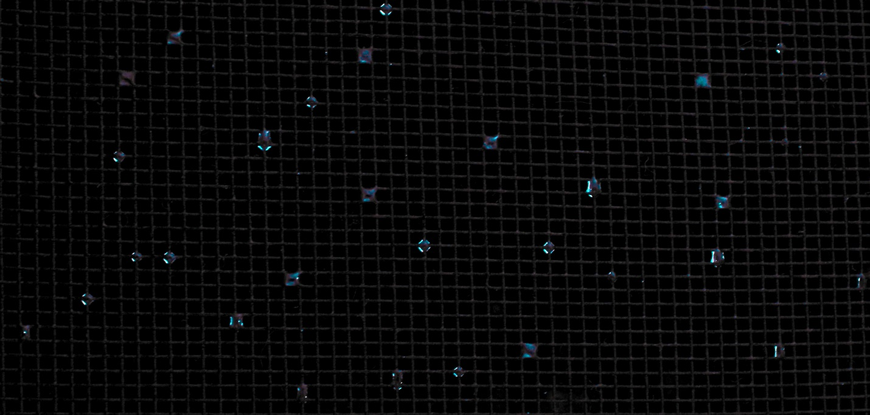

**Team 2 Report: Droplets on a Window Screen**

Kate French

11/6/2024

Flow Visualization Fall 2024

[Team Members: Sarah Hastings and Lia Cucuzzella]

**Introduction:**

As the seasons began to transition and the night started to become colder at the beginning of October, I found my attention caught by a fascinating fluid pattern. After a long, hot shower, some of the steam escaping the room through the bathroom window condensed on the window’s screen. The lower night temperatures caused the steam to condense, creating a lattice of droplets on the screen. I was mesmerized by the fairly random location and dispersed locations of the droplets, as well as the differences in their behavior: some of the droplets formed around the juncture of the screen threads, creating a spheroid around the juncture, while some formed a concave surface filling a square between fibers. My goal in this image was to capture the night-sky-like aesthetic of the sporadic drop pattern, as well as the variety in their form.

**Fluid Mechanics:**

***Figure 1.*** *Set-Up.*

As shown in Figure 1, the set-up consisted of a window screen (shown as a teal rectangle), with hot, steamy air inside, and cold night air outside. This contrast of temperatures and humidities caused water droplets to condense on the screen, creating water droplets on the mesh of the screen.

I have continued to be fascinated by this phenomenon as the autumn nights have gotten increasingly chilly; each time, the number of droplets is fascinating, and they form a delicate lacework like the stars in the night sky, before steadily disappearing without a fanfare. I am quite curious as to the patterns that cause their initial emergence/distribution, and the mechanisms by which they vanish, because they appear to simply evaporate, rather than dripping down like they might on a solid wall, but they almost seem to disappear between blinks. The timespan of this image is inconsequential – the droplets were not “moving,” necessarily, even as they slowly vanished over the course of approximately a quarter-hour.

While it is obvious that the screen and the highlights of the rounder droplets are in focus, the droplets spanning a square give the illusion of being less in focus, despite being in the same plane as the elements in good focus. In theory, this is due to them acting as a lens.

*Most of the experiments I could find were for horizontal screens, rather than vertical ones, which I found disappointing. (*[*https://www.sciencedirect.com/science/article/pii/S0894177716303144*](https://www.sciencedirect.com/science/article/pii/S0894177716303144) *and* [*https://www.sciencedirect.com/science/article/pii/S0301932201000611*](https://www.sciencedirect.com/science/article/pii/S0301932201000611)*, for instance.) I intend to perform more research into what cause the fluid phenomena I perceived. Surface tension, cohesion, and adhesion are obviously quite relevant.*

**Photographic Procedure:**

The original photo was taken with a Nikon COOLPIX P500, a compact digital camera. The focal length was 7 mm, and the original picture dimensions were 4000 x 3000 pixels. The camera was held approximately 6-8 inches away from the screen by hand in order to dynamically capture the most interesting droplet patterns as the droplets evaporated out the window. I also chose the framing to take advantage of the dark night outside of the window; I didn’t want to get any street lights, parking lot features, or other distracting mundane content in the background.

The f-stop was f/4, the ISO was 160, the max aperture was 3.5, and the shutter speed was 1/15 sec. I chose a medium-to-small f-stop, because I wasn’t necessarily looking for a large depth of field; I wanted to capture the droplets without the background being especially distinct. The ISO was also fairly low in order to avoid graininess and avoid saturation. The flow was not moving, so an extremely fast shutter speed was not required; the shutter speed was selected as the final variable to create a reasonable overall exposure level with the f/stop and ISO being more significant to my desired effects. I selected a shutter speed that was fast enough that any jitters from my holding the camera manually were not visible as motion blur.

The lighting was simply the bathroom lights that came installed in my apartment: soft white stage makeup lights on the same wall as the window, located approximately 10, 16, and 22 inches away from the center of the image respectively.

The image underwent a relatively extensive set of post-processing steps in Darktable. The initial image can be seen below inFigure 3.

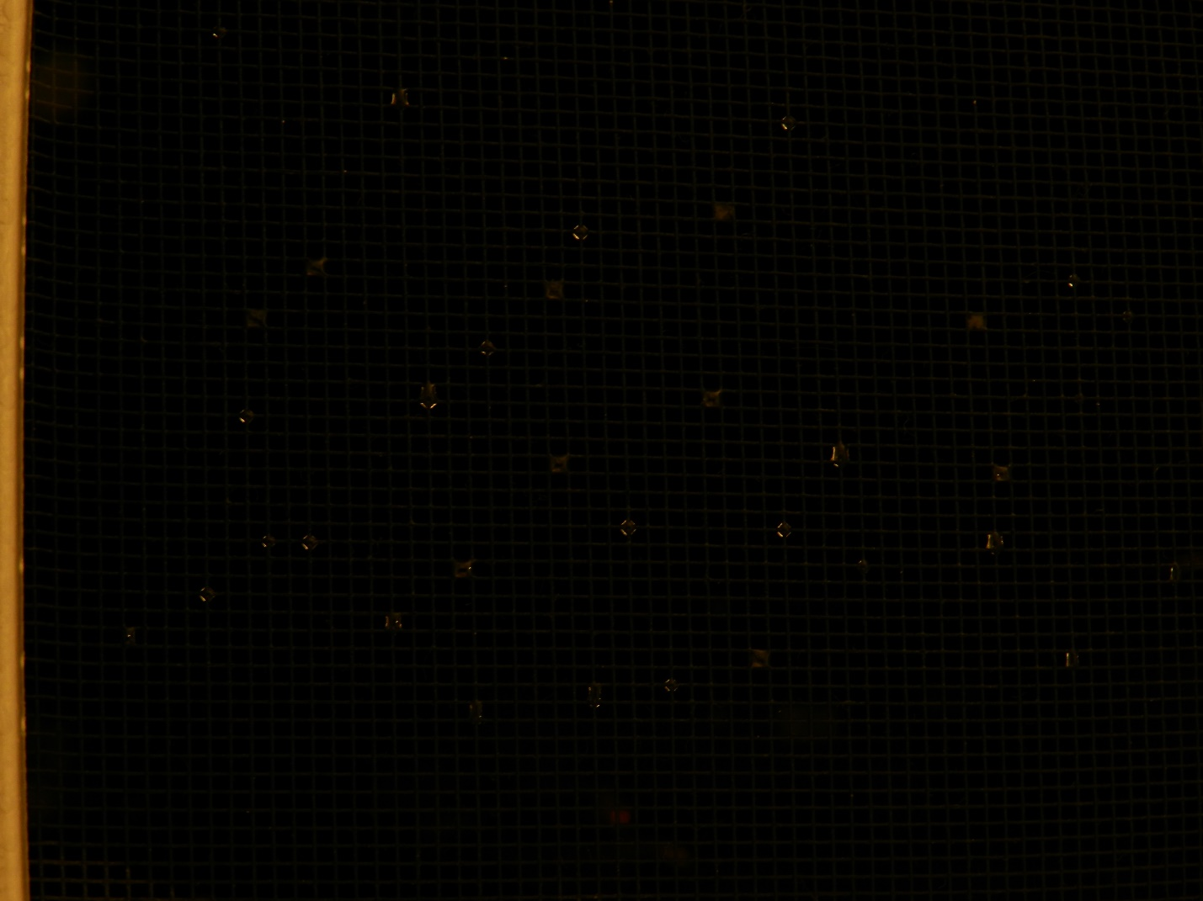

***Figure 3****. Unedited image*

The image was cropped to remove the side of the sliding window and to highlight more interesting droplets along the rule-of-thirds thirds lines. This left final dimensions of 3615 x 1725 pixels. The final field of view was approximately 5 in x 2.4 in.

As seen above, the original image was quite dark. I increased the exposure (0🡪3.7584), changed the color zones, RGB curve, and color equalizer to move from orange-yellow tones to blue-purple tones. I wanted to enhance the differences between the highlights and the shadows of the droplets, which I was able to do by making the “orange” shadowier segments of the droplets more purple, compared to the blue and white highlights of the droplets. I also wanted to make the screen less important in the image – while the original image did not highlight the screen hardly at all, the increased exposure made the screen fairly distracting, and decreasing its colors’ brightness helped it become more of a background feature again. I wanted it to be somewhat visible in order to demonstrate the flow patterns involving it, but I didn’t want it to be too distracting.

**Conclusion:**

Overall, I am pleased with my image. I am mildly irked by some of the droplets looking out of focus, even though the convex droplets and screen are both obviously in focus. I know that this is due to physics, but I still wish that I was able to get a more visually punchy image. I considered recreating the experiment conditions in a more controlled fashion (e.g. by boiling water in a kettle right inside of the window), but I was fairly pleased with how the image turned out, so I did not wish to invest resources in a repeat, when the original was quite acceptable. I was advised to look into focus stacking to perhaps get more layers in focus, and I would be interested in potentially recreating this image using that technique.

I wanted to get an image with many droplets, especially because the varied spacing was so interesting to me, but they kept disappearing as I tried to frame the shot…