**Visualizing Hurricane-Like Turbulence in a Boiling Shaving Cream-Water Mixture**

Caidan  
 MCEN 4151  
 December 4, 2024  
**Acknowledgments:** Samuel Hatton assisted with setup and video capture.

### **Context and Purpose**

This report documents a flow visualization experiment aimed at replicating hurricane-like turbulence in a controlled environment. A rectangular glass container, filled with a mixture of shaving cream and water, was heated using two submersible coil heaters to induce chaotic flow patterns. The goal was to capture the dynamics of thermally driven turbulence and buoyancy-driven vortices, showcasing hurricane-like structures in the laboratory.

Initial trials using plain water failed to produce visually identifiable flow structures, prompting the use of shaving cream to enhance contrast and visibility. Videos were captured using an iPhone 15 Pro at 120 and 240 frames per second, enabling high temporal resolution for motion analysis.

### **Apparatus and Flow Description**

#### **Setup**

The flow experiment was conducted in a rectangular glass container with dimensions of 10 cm in width, 15 cm in height, and 8 cm in depth. The container was partially filled with a 1:10 mixture of shaving cream and water, ensuring a sufficient volume for observable turbulence. Two submersible coil mug heaters, each rated at 300 W, were placed along the container's base, positioned symmetrically to promote even heating.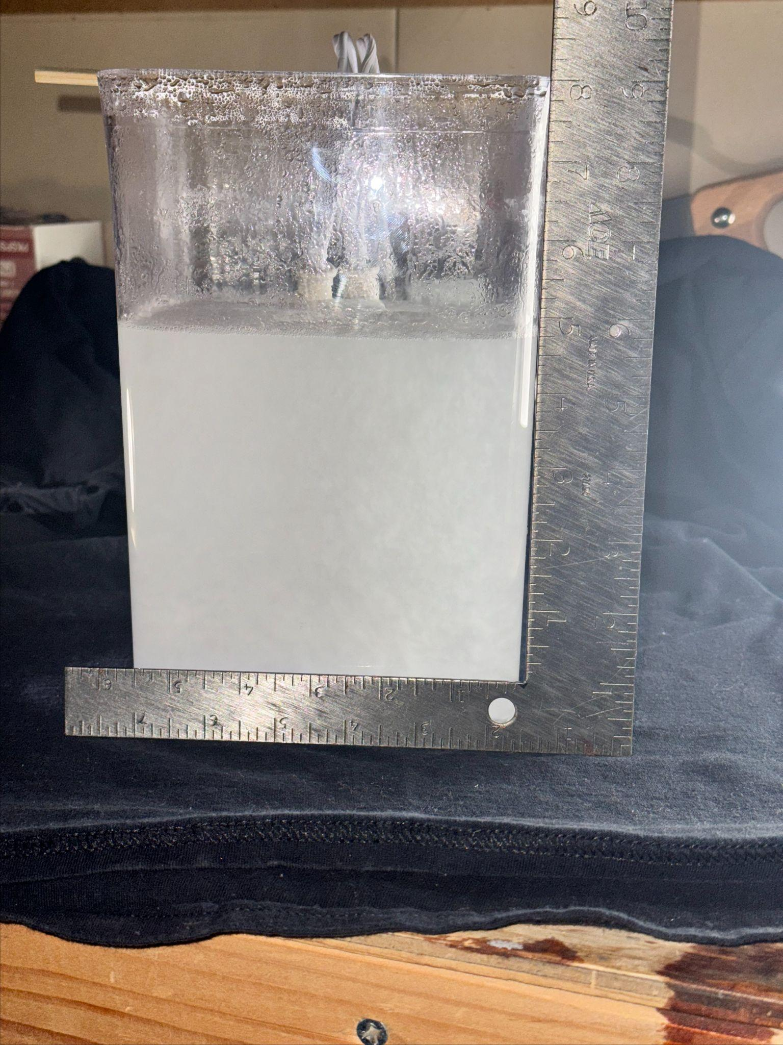

#### **Flow Physics**

The heaters created a strong thermal gradient at the bottom of the container, causing the fluid to boil and expand. The rising, heated fluid formed a low-density core, which ascended toward the surface. This motion established a convection current: cooler, denser fluid from the top and sides descended to replace the rising fluid. These thermal and density-driven forces are analogous to the energy transfers in atmospheric hurricanes, where warm air near the ocean's surface rises, and cooler air descends.

The flow dynamics are described by two key forces:

1. **Buoyancy:** The temperature difference ($ΔT$) between the hot base and cooler upper layers drove the fluid upward, generating convection.
2. **Shear Forces:** Interaction between ascending and descending flows created velocity gradients, generating shear layers and turbulence.

The heaters' placement caused the formation of two primary vortices, analogous to a hurricane's eye wall. The flow was characterized by turbulence, as evidenced by chaotic motion and energy dissipation into smaller eddies.

#### **Calculations**

To quantify the flow, the Grashof number ($Gr$) and Reynolds number ($Re$) were calculated:

$Gr=\frac{gβΔTL^{3}}{υ^{2}}$ $Re=\frac{UL}{ν}$

Where:

* $g=9.81m/s^{2}$ (gravitational acceleration)
* $β=0.00021K^{-1}$ (thermal expansion coefficient of water)
* $ΔT≈40C$ (temperature difference)
* $L=0.1m$ (characteristic length, approximate heater spacing)
* $υ=1×10^{-6}m^{2}/s$ (kinematic viscosity of water)

The Grashof number was estimated as:

$Gr≈8.2×10^{8}$

The Reynolds number, using $U≈0.1m/s$ (estimated fluid velocity), was calculated as:

$Re≈10,000$

These values confirm that the flow was highly turbulent ($Gr>10^{8},Re>4,000$

### **Hurricane-Like Flow Behavior**

The hurricane analogy arises from the central upwelling of fluid and the rotational symmetry of the flow. Key observations include:

#### **Vortex Formation**

The central region of the container displayed a strong upward flow, akin to a hurricane's low-pressure eye. Surrounding this core were counter-rotating vortices, analogous to the eye wall in hurricanes. These vortices were sustained by the continued convection currents generated by the heaters.

#### **Secondary Eddies and Banding**

The interaction between the ascending core and descending cooler fluid created secondary vortices along the container's edges. These smaller eddies mimic the rain bands in a hurricane, where turbulence and mixing dominate. The shearing motion at the boundaries further amplified these structures.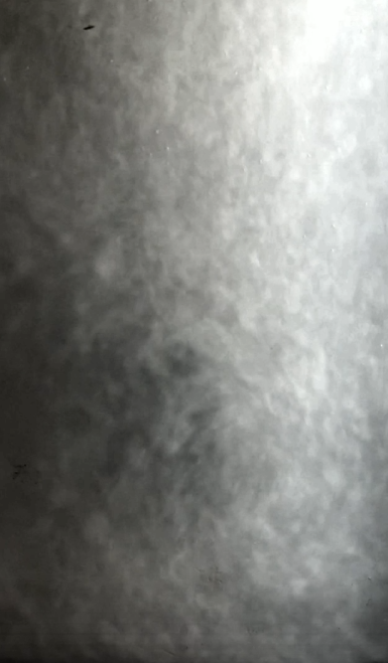

#### **Flow Instabilities**

The transition between laminar and turbulent flow, visible in the chaotic behavior of the shaving cream particles, highlighted the instabilities present in the system. The experiment visually demonstrated Kelvin-Helmholtz instabilities, where velocity gradients between fluid layers created wave-like patterns.

### **Visualization Technique**

The shaving cream served as a passive tracer, revealing flow paths and turbulence. The mixture enhanced the visualization of both large-scale vortices and smaller turbulent eddies. Environmental conditions were controlled, with room temperature maintained at 20 degrees (Celsius) and external disturbances minimized.

Lighting was provided by two LED lamps placed at 45° angles, ensuring uniform illumination. A black fabric backdrop reduced reflections and improved contrast.

### **Photographic Technique**

The iPhone 15 Pro captured high-speed video at 120 and 240 fps, providing sufficient temporal resolution to analyze turbulent motion. Videos were recorded in 1920x1080 resolution using the H.264 codec. The phone was positioned 30 cm from the container, with its lens centered at the fluid's mid-height.

Post-processing involved adjusting contrast and saturation in Adobe Lightroom to enhance the visibility of vortices and turbulent structures.

### **Image and Flow Analysis**

The visualization effectively captured hurricane-like turbulence, with prominent central upwelling, rotational vortices, and smaller eddies. The shaving cream particles provided clear contrast, although residue on the container walls slightly obscured visibility.

Future improvements could include using neutrally buoyant particles or implementing a rotating platform to simulate the Coriolis effect. Additionally, quantitative tools, such as particle image velocimetry (PIV), could provide detailed velocity field measurements.

This experiment successfully demonstrated the principles of buoyancy-driven turbulence and offered insights into hurricane-like flow behavior. It serves as a foundation for further exploration of thermally driven vortices and turbulent convection.

**References**

1. Alvi, F. (n.d.). *Grashof Number and Rayleigh Number*. Retrieved from https://eng-web1.eng.famu.fsu.edu/~alvi/EML3016/Lecture-notes-new/free%20convection/tsld003.htm
2. Typeset.io. (n.d.). *How does boiling of water induce turbulence due to the bubbles?* Retrieved from https://typeset.io/questions/how-does-boiling-of-water-induces-turbulance-due-to-the-1spdl2n5re
3. Wikipedia. (n.d.). *Grashof Number*. Retrieved from<https://en.wikipedia.org/wiki/Grashof_number>
4. Durian, D. J., & Weitz, D. A. (1991). Scaling behavior in shaving cream. *Physical Review A*, *44*(R), 7902. Retrieved from https://link.aps.org/doi/10.1103/PhysRevA.44.R7902
5. Testbook.com. (n.d.). *Grashof Number: Know Formula, Significance, and Example*. Retrieved from https://testbook.com/mechanical-engineering/grashof-number