Dry Ice Leidenfrost

Team Third Report
Tara Fisch
12/4/2024
Flow Visualization MCEN – 002

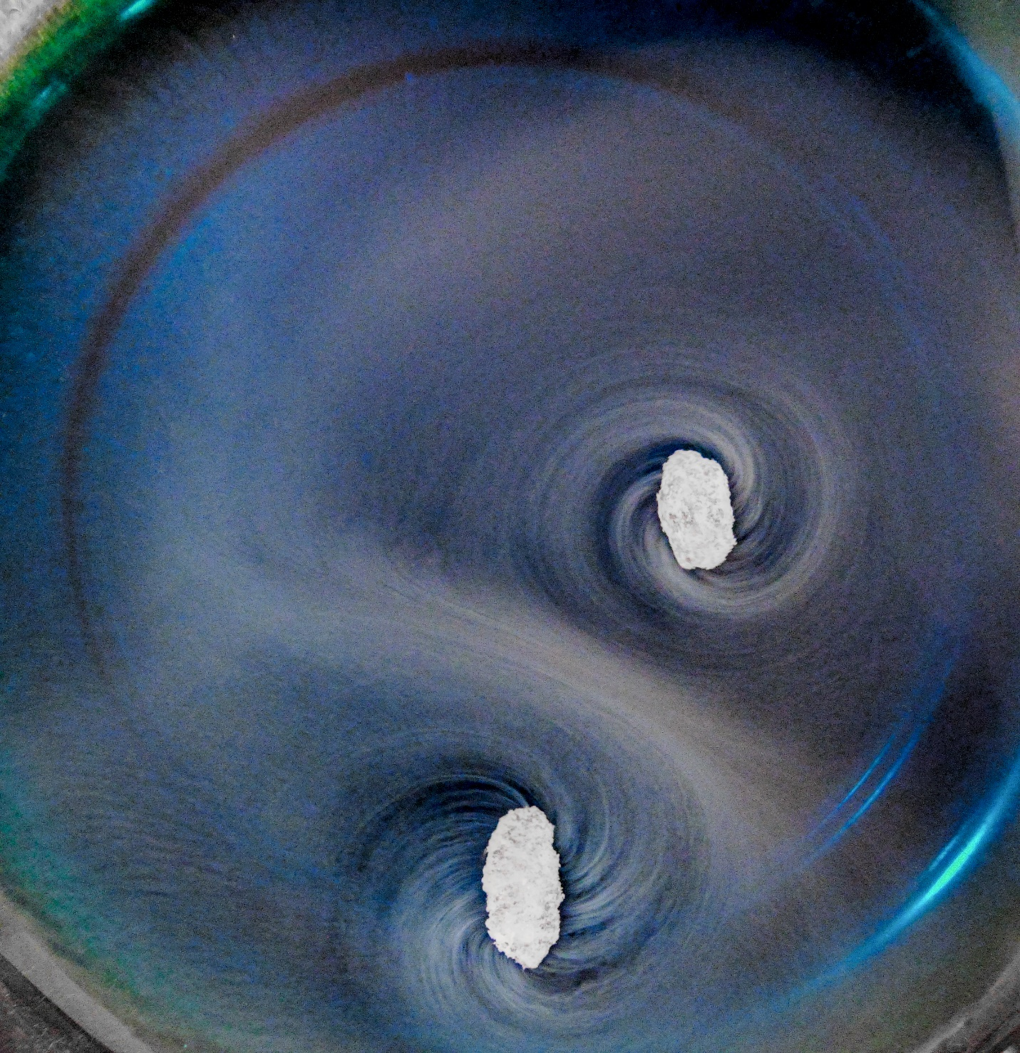

Introduction and Context
This image is an extension from the photograph taken for Team First. While playing with dry ice, I noticed that small pieces of dry ice would end up floating on top of water. When a large piece of dry ice was placed in water, it would sink, but once it became small enough it would pop to the surface and float, acting similar to an air hockey puck during a game of air hockey. Depending on the geometry of the piece of CO2, it would travel quickly across the surface of the water in straight lines, spin rapidly in one place, or spin and travel across the surface. I wanted to capture the motion of a piece of CO2 as it floated on top of the water.

Apparatus, Physics and Flow
To create this image a shallow bowl was filled with water and blue food coloring. Pieces of dry ice were dropped in the water. After waiting until they became small enough to pop up to the surface, it was time to begin the photoshoot. As the smaller pieces sublimated a light layer of CO2 gas would lay on top of the bowl of water.
Dry ice is heavier than water with a density of 1.56g/cm3, although it varies as the solid sublimates, but in general the higher density causes the solid to sink in water. Sublimation is when a solid transforms directly into a gas, skipping the liquid phase. Dry ice sublimates at -78.5 C at atmospheric pressure. The Leidenfrost phenomena will be discussed to understand the image above. Leidenfrost describes “a volatile liquid droplet may hover on a cushion of its own vapor above a surface at a temperature significantly exceeding the saturation temperature of the droplet” [1]. This concept is visualized below in figure 1.

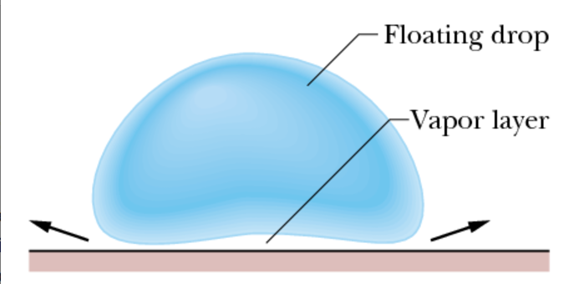
Figure 1. Shows the Leidenfrost effect with a droplet of liquid interacting with a high temperature surface. [2]
This phenomenon is understood for a liquid interacting with a hot surface, but a similar effect can arise in a solid case. “Although the fundamental origin of the Leidenfrost effect might be the same as in the case of a Leidenfrost droplet, the Leidenfrost dynamics of a Leidenfrost solid are expected to differ from that of liquids” [1]. In the case of the photograph, when the piece of dry ice is small enough the force from sublimation overcomes the weight of the dry ice, propelling it to the surface of the water. The small piece of dry ice then floats on a small layer of CO2 and does not appear to interact with the surface of the water. The image does not show any ripples or disturbances in the water, inferring that the previous statement is true. The Leidenfrost effect in solids is more difficult to study because of the tendency for propulsion on structured surfaces [2]. In the photo the structured surface is water, and the propulsion can be seen in the gas spirals that trial off from the solid CO2 as it sublimates. The image captures the Leidenfrost dynamics of a solid.

Visualization Technique
To visualize the flow, a marked boundary is used. The marked boundary is seen by the white CO2 gas and the blue died water. The flow of the CO2 gas is visible as lines coming off of the solid turns to gas causing the small solid CO2 piece to spin. There were overhead lights on when the image was taken and there was noticeable light coming in through the windows.

Photographic Technique
The photograph was captured using a Sony 6500. The field of view of the image was approximately 1’ x 1’. This was chosen so that the camera lens was close to the subject, approximately 1.5’ away. Minimal zooming was used to focus on the spinning pieces of CO2. The image was shot with a shutter speed of 125, ISO 8000 and an aperture of 4.5. These settings were chosen to minimize motion blur due to the fast movement of the CO2 pieces. There was minimal post processing done to the photo. This included cropping and increasing the contrast to make the gas lines more defined.

Conclusion
The image captures rotational moment of a solid caused by sublimation and the Leidenfrost effect. I like the movement that is captured in the still image. If I were to change something I would change the background of the image to that the corners have a consistent appearance. To develop this idea further, different geometries could be cut from the dry ice to see what other types of motion the pieces of dry ice will see due to sublimation.

References
[1] Purandare, A.S., et al. “Experimental and theoretical investigation of the Leidenfrost dynamics of
solid carbon dioxide discs sublimating on a solid substrate” International Journal of Heat and Mass Transfer, Volume 224, (2024).
[2] Walker, Jearl D.. “BOILING AND THE LEIDENFROST EFFECT.” (2000).

