Droplets on Leaves
Team Second Report
Tara Fisch
11/6/2024
Flow Visualization MCEN – 002

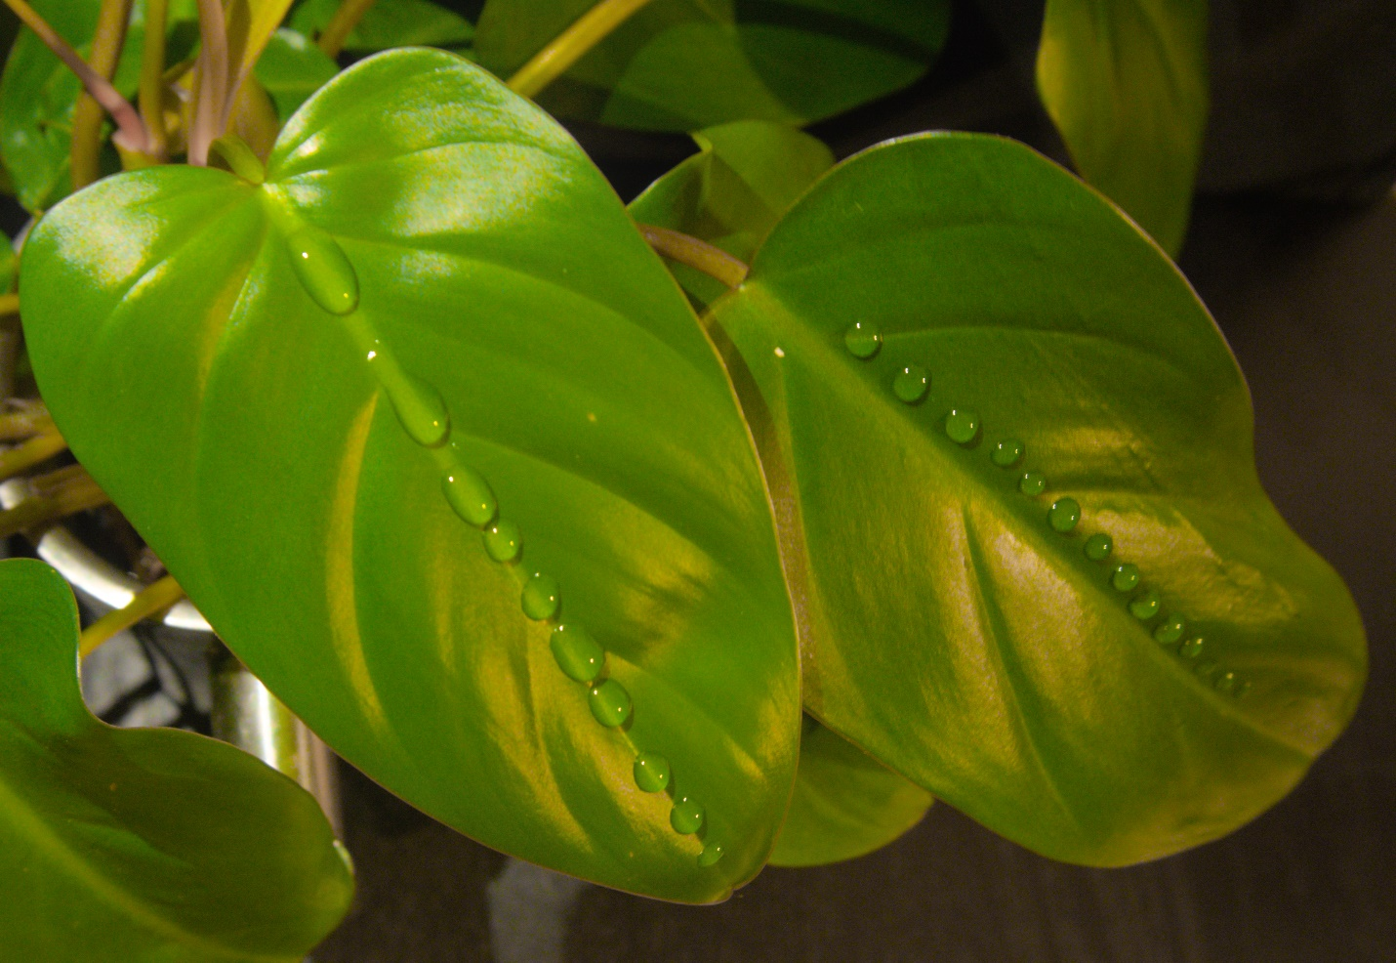

Context
This photo seeks to visualize surface tension of water. Many of us have experimented with dropping water on a coin to see how big of a water bubble forms before the surface tension breaks causing the water to flow. I got to thinking what else would look cool with droplets of water on it. I have a lot of indoor plants, some are in the bathroom, and I have noticed that when the small room gets steamy from a shower, water condensates forming droplets that hang from the leaves. This made me think what if I put water droplets on the leaves instead of waiting for the droplets to form naturally. The image uses the leaves of a philodendron.

Fluid Discussion
Water is known to have high surface tension. We will first define cohesion, adhesion and van der Waals forces. Cohesion is the attraction of similar fluid molecules to each other. Water molecules are highly attracted to themselves. Adhesion is the attractive forces between two dissimilar molecules like a liquid and a gas, here we will focus on water and air. Van der Waals forces are weak intermolecular forces that depend on the distance between molecules and no do involve chemical bonding. Finally, we get to surface tension, “defined as the work required to increase the area of a surface isothermally and reversibly by unit amount” [1] or a liquid’s tendency to move so that it has the smallest possible surface area. The cohesive forces in the water are more than the adhesive forces between the gas and liquid, which causes a pressure difference that results in a change of shape of the liquid. Surface tension will be denoted $γ$ in following equations and figures.
In the image, a small amount of liquid meets a solid surface, a leaf. The liquid has cohesive forces with itself, adhesive forces with the solid, and van der Waals forces with the gas, or vapor, surrounding it. All these forces are interacting with each other and the liquid is in equilibrium. A visual of what happens at the gas liquid interface of water on a dry surface is shown below in figure 1.

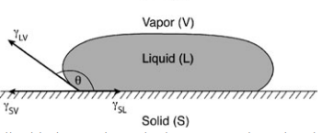
Figure 1: shows how water moves to have smallest surface area, it costs more energy to take up more surface area [2].
The labels in figure 1 are as follows: $θ$is the contact angle between the liquid surface and the solid surface, ${γ }_{LV}$ is the surface tension at the liquid vapor interface, ${γ }_{SV}$ is the surface tension at the solid vapor interface, and ${γ }_{SL}$ is the surface tension at the solid liquid interface. Figure 1 relates more to the right leaf with more uniform droplets running along the center of the leaf. All droplets on the right leaf were placed and did not move/ join into larger droplets prior to the photo being taken. So, they remained on the initial dry surface they were placed on. While placing the droplets on the leaf on the left, at times I would drop too much water, the surface tension would break, and water would flow off the leaf. I tried to wipe the leave dry with a paper towel, but this still left a wet surface. When placing the droplets on a wetted surface, the droplets took on a slightly different shown in figure 2.

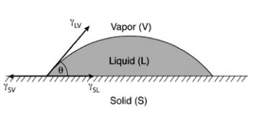
Figure 2: shows the shape of small volume of water when placed on a wetted surface [2].

Looking at the second droplet from the top on the left leaf in the image, it looks more like the shape in figure 2. The image does a good job at showing that water can take on different shapes when in contact with wet and dry surfaces. Although the two figures show ${γ }_{LV}$acting in different directions, both are perpendicular to the surface of the water making ${γ }_{LV}$ always positive [1]. Both figures show water at equilibrium, and as mentioned above this scenario has cohesive, adhesive and van der Waals forces acting at the interfaces are related in the Young Dupre equation shown in equation 1.
${γ }_{LV}\cos{θ= {γ }_{SV}-{γ }_{SL}}$ Eq. (1)
Which states that contact angle depends only on surface tension. It does not depend on the solid liquid system [2]. Surface tension of liquids (${γ }_{LV})$can be measured directly but ${γ }_{SV}$, and ${γ }_{SL}$ cannot be, therefore using equation is not often done in practice. For further information about methods to measure ${γ }_{SV} and {γ }_{SL}$ see reference 1. The above figures assume that the solid is horizontal, in the image the weight of gravity acting on the droplets on the sloped leaves will affect the equilibrium of the droplet. Once the weight of the droplet overcomes the force of gravity and the cohesive forces holding the droplet together, it will change shape and flow down the leaf.

Visualization Technique
To bring this visualization to life, I used a small pipet to gently place water droplets on the leaves. The leaves were sloped down, so if a water droplet was too big, it would slide down into the other droplets and flow off the leaves. The leaves of the philodendron are waxy and repel water well, making the surface tension on each drop easy to see. The photo was taken at night, so there was no light from the windows, but the overhead lights in the room were on. There was no flash used when taking the photo. A flash light was pointed behind and parallel to the direction of the center of the leaf on the left. This lighting caused there to be some glare on the left leave that was addressed in post processing.

Photographic Technique
The field of view was approximately 1.5’ x 1’. The camera was held about a 1’ away from the leaves. I tried to get close to the leaves and adjust the zoom to bring the droplets into focus. This took quite a long time to get the image to come into focus that I liked. The image was shot with a Sony 6500 at 1000 ISO, aperture of 5.6 of and shutter speed of 1/8.
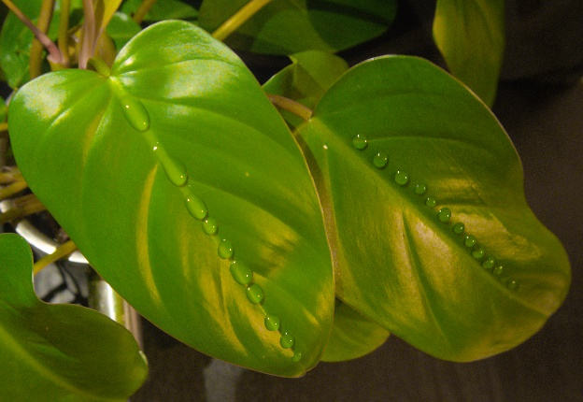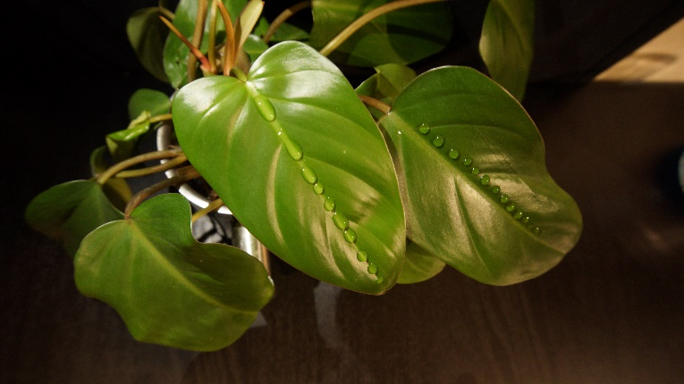
Edited: 3737 x 2576 pixels Unedited: 6000 x 3376 pixels
In post processing I used the color equalizer to decrease the glare on the left leaf. I cropped the image so that the leaves in the background do not distract from the leaves with droplets.

Final Comments
The image does a great job at showing surface tension of water. I like how the droplets on the right leaf are more uniform in size. While putting the droplets on the left leaf, the water would slide down leaving a small trail of water, I tried to dry the leaf before reapplying droplets, but once the leaf was a little wet the droplets wanted to slide down the leaf more. The second droplet on the left leaf looks as though it is about to flow. In the future I would try to make all the droplets about the same size. To develop this idea further, I would want to experiment with other types of leaves to see if there is a leaf that allows for larger water droplets and how big a droplet can be.
References
[1] Ebnesajjad, Sina. “3 - Surface Tension and Its Measurement” In Plastics Design Library, Handbook
of Adhesives and Surface Preparation, William Andrew Publishing, 2011. Pages 21-30.

[2] Sophocleous, Mario. “Understanding and explaining surface tension and capillarity: an
introduction to fundamental physics for water professionals.” Hydrogeology Journal. 2010.

