Water Tunnel Instructions

Originally created: 12-18-24 by Sarah Hastings

Last Modified: 12-18-24 by Sarah Hastings

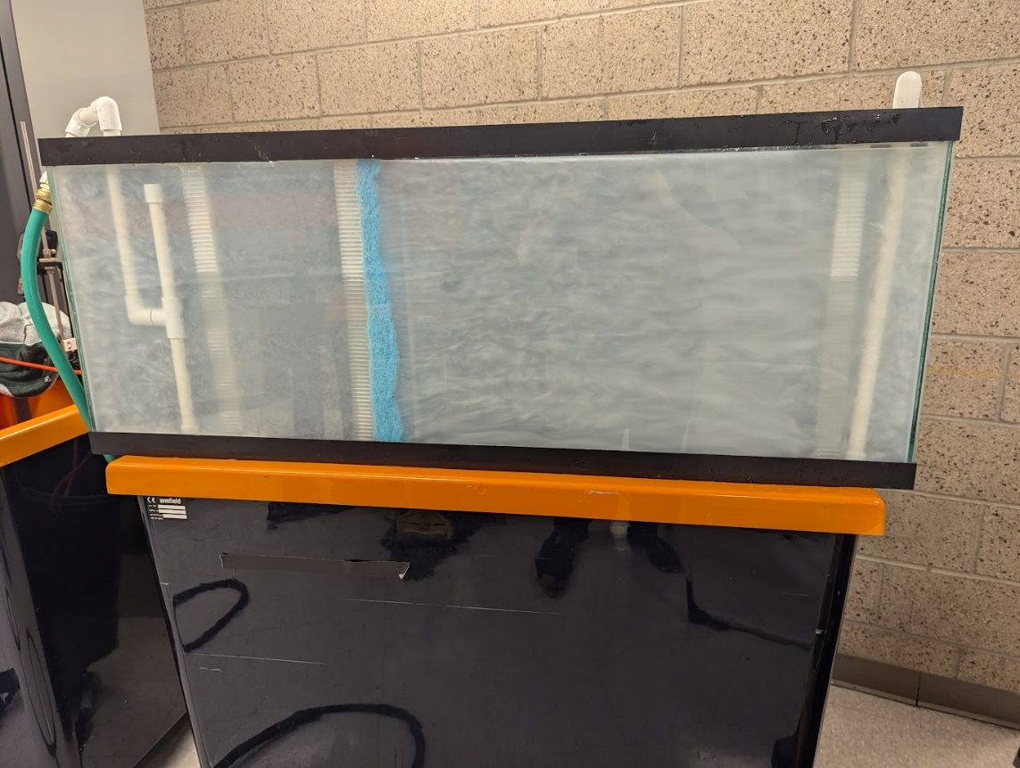

Figure 1: Water tank filled with rheoscopic fluid

# Overview

The water tank system is shown in Figure 2. Starting from the inflow hose, the water flows as follows:

1. The water enters the inflow distributor and enters the tank as jets emitting from the holes in the distributor. The flow immediately following this is extremely turbulent.
2. The water goes through a grid-type flow straightener, which helps even out the velocity profile.
3. After some distance in the tank to further even out any velocity gradients, the water goes through a dual flow straightener, one more grid-type one, and an open foam one. This significantly slows and straightens the flow, producing nearly laminar flow in the test section.
4. The water passes through the test section and into one more grid-type flow straightener, which reduces the effect the widely spaced drain holes in the outflow collector have on the test section flow.
5. The water enters the outflow hose which leads to a pump, and the water is pumped back into the inflow distributor.

In

Test section

Upstream flow straightener 1

Upstream flow straightener 2

Downstream flow straightener

Inflow hose

Outflow hose

Out

Inflow distributor

Outflow collector

Downstream system supports

Downstream system supports

Flow straightener support

Figure 2: Part identification (tank not shown for clarity)

# Setup Instructions

1. Clean the inside of the water tank, especially the glass in front of the test section. If the tank has accumulated a significant amount of dirt and other large particles, this can be done by filling the tank with water, mixing it, and using a siphon to empty the tank, removing most of the dirt with it
   1. Instructions for starting siphon: Place one end of a garden hose in the tank and turn on the hose, filling the hose with water. Submerge the end of the hose in the tank water and turn off the water. As long as the spigot end of the hose is lower than the end in the tank, water will begin to flow backwards in the hose toward the spigot. Unscrew the hose from the spigot and let the water drain. The area in the ITLL by the flume (level 2B) has a spigot right above a drain that makes this convenient.
2. Locate the large black backing board for the test section. Attach the pieces shown in Figure 2, except the hoses. A photo of this setup is shown in Figure 3. The backing board has a matte side and a shiny side. The matte side should be facing up to reduce glare in later photography.  
   A black and white stretcher with white tubes

   Description automatically generated

Figure 3: Test section before submersion in tank

**Caution: The wire attaching the open cell foam to the grid straightener in flow straightener 2 is sharp. Be careful when handling this piece.**

1. Place the test section in the tank. Slide the backing board vertically down into the tank. The board is slightly too wide to fit, so there are two slots cut into the top of the tank where the board can slide through. Slide the board down, then move it forward until the plastic supports touch the wall of the tank.
2. Attach the hoses to the pump as shown in Figure 4. The pump receives water from the black hose (right) and pumps it through the green garden hose (bottom).  
   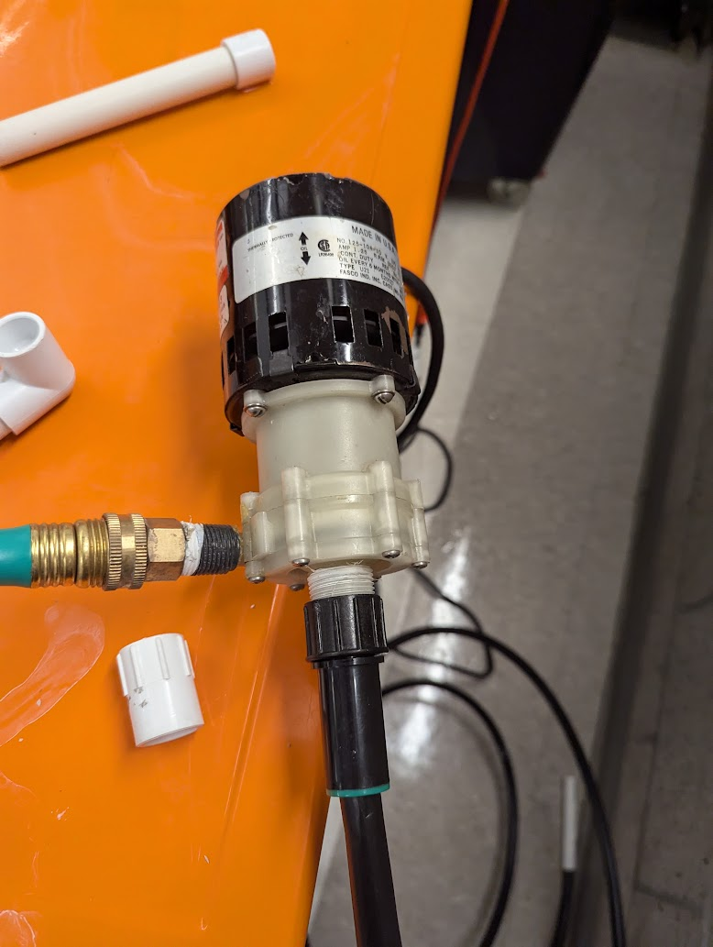

Figure 4: Pump with attached hoses

1. Connect the other end of the green hose to the inflow system as shown in Figure 5. The garden hose connects to a metal fitting connected to the PVC system. Do not connect the black hose yet.  
   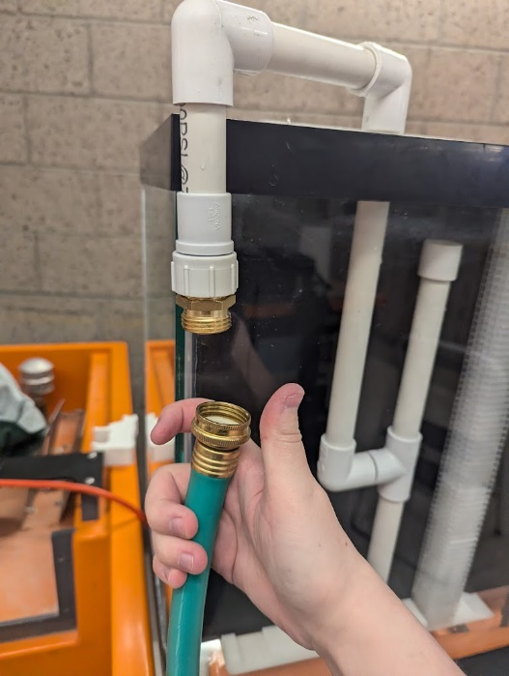

Figure 5: Inflow hose connection

1. Fill the tank with enough water (or whatever fluid is being used) to completely submerge all the holes in the outflow collector. Do not fill the tank too full, since a later step requires adding a little water to the tank.
2. **IMPORTANT:** The pump that comes with the water tank cannot pull a vacuum, meaning that it cannot operate if any significant amount of air is in the pump system. Doing so for any length of time will damage the pump. For this reason, the system must be filled with water before turning the pump on.
   1. Connect the piece shown in Figure 6 to the end of a garden hose connected to a spigot.  
      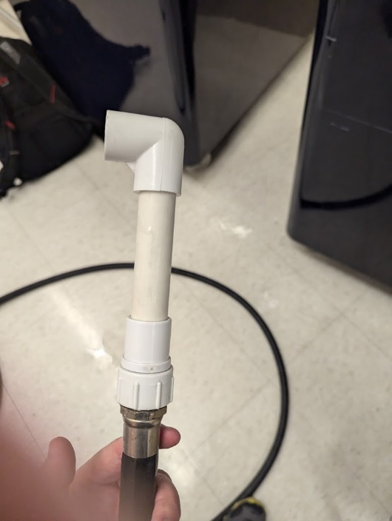

Figure 6: Hose adapter

* 1. Connect the other end of the hose adaptor shown in Figure 6 to the unconnected end of the thin black outflow hose shown in Figure 2. Turn on the spigot, running water through the outflow hose and the pump. This will send bubbles through the inflow distributor until the air is purged from the system. When the bubbles stop, turn off the spigot. Water will start to siphon back through the hose, but this is okay.
  2. Disconnect the outflow hose from the garden hose adaptor and plug it into the outflow collector system as shown in Figure 7. This step must be done as rapidly as possible to minimize the amount of air that enters the system.  
     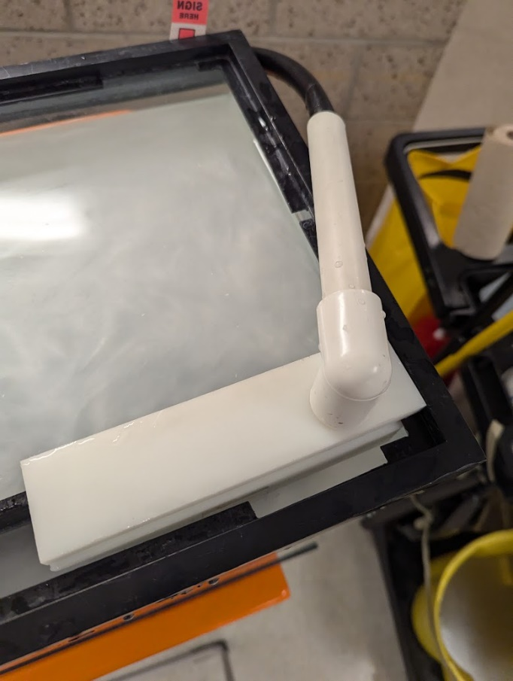

Figure 7: Connected outflow hose

* 1. Switch the pump on. If rheoscopic fluid is in the tank, there should be visible fluid flow from the inflow distributor in the tank. If only water is in the tank, feel around the holes for water flow. If it worked, there would be a burst of bubbles, then a steady stream of water. If not, there would be no flow in the tank. If there is no flow in the tank, shut off the pump and try again.
     1. If repeated attempts to purge the air from the system do not get flow in the tank, the outflow collector system can be removed from its support and fully submerged. Then, the hose adaptor can also be submerged when it is disconnected, and the outflow hose can be connected to the system while fully submerged. This will always work to remove the air, but it is more difficult to do.

1. Secure the backing board to the front of the tank. When the pump system is operating, the backing board tends to drift away from the tank walls. The miscellaneous pieces shown in Figure 8 are all about the right length to brace the backing board against the tank.  
   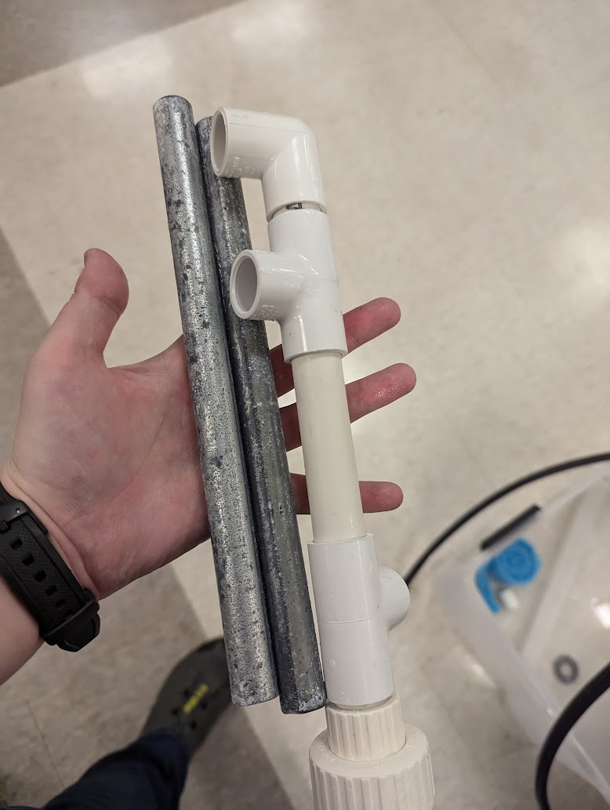

Figure 8: Backing board braces

1. If necessary, secure the top of the backing board against the tank with some clamps.

# Operation Tips

* To visualize the flow around a 2D object, a 3D-printed object can be placed in the test section. 3D-printed objects are quite buoyant, which can make it difficult to get the object to stay down in the test section. If the object is designed so that it has an interior which may fill with water (designing a cylinder as a bottle-cap shape, for example), then the object will have a more neutral buoyancy.
* Plumber’s putty can be stuck to the back of objects placed in the test section to help them adhere to the backing board. However, this is not enough on its own, so clamping the backing board to the tank front can help hold objects in place. It is often helpful to keep a couple of long sticks to maneuver objects in the narrow test section.
* Before taking photos, check that the backing board has remained vertical. If it becomes crooked, the width of the test section will vary, introducing an expansion into the flow. This will cause non-uniform changes in the velocity field.
* If possible, avoid draining the tank below the level of the holes in the outflow collector. As long as the pump system stays submerged, it does not need to be purged of air again.
* If turbulent flow in the tank is desired, the second flow straightener can be removed, which creates fairly uniform turbulence.
* Placing the tank on one of the ITLL’s hydraulic benches is convenient because of proximity to the ITLL’s water supply and drains. Additionally, the hydraulic benches have wheels, making the system portable. The nearby room in the ITLL with the fume hood can be darkened completely when both sets of doors are closed, creating a convenient photography location with full control of lighting.

# Rheoscopic Fluid Instructions

Shaving cream can be used to create a rheoscopic fluid to visualize the flow in the tank (Borrero-Echeverry, Crowley, & Riddick, 2018). Instructions are as follows:

1. Obtain several cans of shaving cream (like [this](https://www.target.com/p/ocean-scented-shaving-foam-10oz-smartly-8482/-/A-75557153?ref=tgt_adv_xsp&AFID=google&fndsrc=tgtao&DFA=71700000086530542&CPNG=PLA_Beauty%2BPersonal+Care%2BShopping_Traffic_Local_Traffic%7CBeauty_Ecomm_Beauty&adgroup=SC_Health%2BBeauty&LID=700000001170770pgs&LNM=PRODUCT_GROUP&network=g&device=c&location=9028882&targetid=pla-895876315184&gad_source=1&gclid=EAIaIQobChMIxY2noZGzigMVqJXuAR0knBjlEAQYASABEgLam_D_BwE&gclsrc=aw.ds) one, which is cheap and can be purchased from Target). The instructions that follow are assuming 10-oz cans of shaving cream.
2. Empty one entire can of shaving cream into a five-gallon bucket.
3. Add about 1.5 gallons of water. This does not need to be an exact measurement.
4. Mix the shaving cream and the water until the mixture is homogeneous. Mixing by hand tends to be faster than with an implement because the foam needs to be pushed down into the liquid.
5. Let the mixture set for a few hours. It will separate into a liquid and a foam. Five gallon buckets are somewhat translucent so this should be visible from the outside.
6. The liquid underneath the foam is a rheoscopic fluid. It may be gently poured out from under the foam into the tank or another storage container. The longer the mixture has been left to set, the sturdier the foam on top will become, and the more it will resist being poured out with the liquid.
7. Dilute the rheoscopic fluid as desired. The fluid in the tank in Figure 1 was made with seven cans of rheoscopic fluid, and the rest of the tank filled with water.

# Suggestions for Improvements

* Find a way to the pumps on the ITLL’s hydraulic benches in place of this pump. The hydraulic bench pumps have flow rate controllers, which would allow control of the flow speed in the tank.
* Attach the flow straightener foam to the grid-type flow straightener in some way that does not involve sharp wires (a needle and thread, maybe).
* Build something to attach the pump to, instead of awkwardly balancing the pump behind the tank.

# References

Borrero-Echeverry, D., Crowley, C. J., & Riddick, T. P. (2018, 8 1). Rheoscopic fluids in a post-Kalliroscope world. *Physics of Fluids*, 30. doi:10.1063/1.5045053